EDUCATION & CHILDREN’S SERVICES

IMPROVEMENT PLAN
2014 - 2015

FOR

ECHT SCHOOL

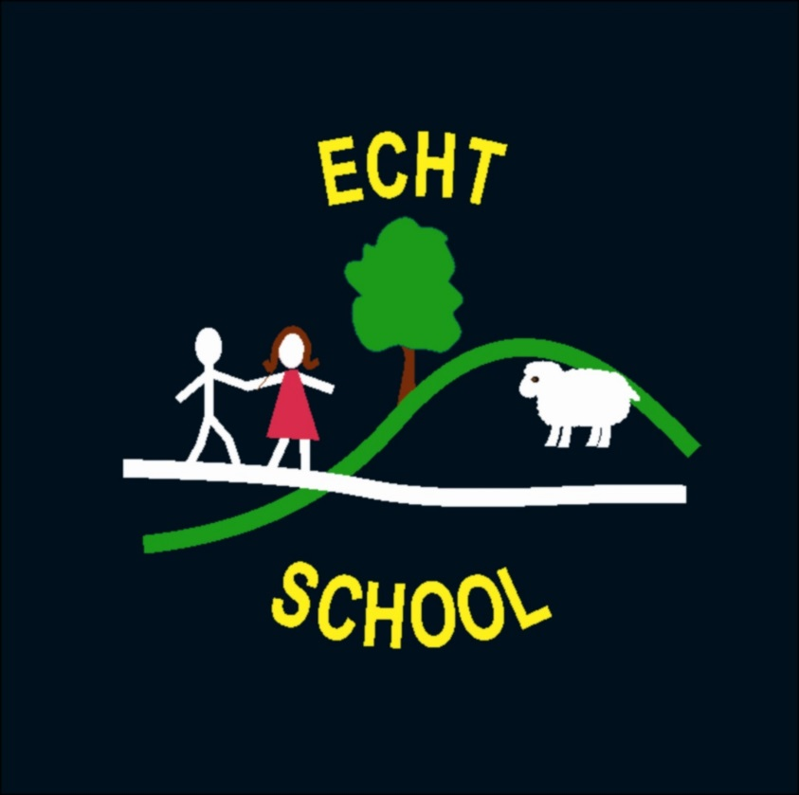

Aberdeenshire Council Education & Children’s Services

“Our vision is for a school in which everyone is able to develop the skills and confidence needed for learning, life and work.”
Echt School

Everyone valued and
Cared for in a
Happy, healthy environment where
Teaching and Learning are fun!

In Echt School our vision is the driving force behind all our improvement activity.

Education & Children’s Service’s Quality Improvement Framework, is the overarching strategic management tool which directs and supports school improvement in establishments across Aberdeenshire. At the heart of the framework is the belief that self evaluation in each school drives improvement and all improvement is aimed at delivering positive outcomes for children and young people.

“Self evaluation is a reflective, professional process through which schools get to know themselves well…Improvement Planning builds on that self knowledge by involving us in understanding and valuing the best of that which already exists, deciding how good we can really be, and identifying the best way forward.
The Journey to Excellence Part 4: Planning for Excellence, HMIe, 2007

Self-evaluation is an on-going process and involves all stakeholders, including our pupils. It is reported annually to parents/carers in our Standards and Quality Report.

Education & Children’s Service Improvement Cycle
Self evaluation to ensure stakeholders commitment
Self evaluation to monitor
and determine progress
Self evaluation to determine impact
Self evaluation to find out
where you have to go

The priorities for improvement contained in the Improvement Plan for 2014 – 15 reflect this process and the priorities identified locally and nationally.

Improvement Priority No. |  |  | 1 | Self-Evaluation
Intended Outcome (s) / Impact |  |  |  |  | Actions / Lead member of staff – Ruth MacDonald | Timescales
- Improved awareness of school's strengths/weaknesses and how these can be built upon/strengthened  - Pupil progress monitored leading to early identification of needs  - Parents more informed of school’s strengths and weaknesses |  |  |  |  | - Continued familiarisation of staff with the 5 main QI’s  - Use of last session’s self-evaluation to inform improvement plan this session  - QI display built up over the session showing evidence of Qi’s we have actioned and in what way  - Use of Staff self-evaluation blogs tagged to key QI’s to inform next steps in learning  - Professional dialogue  - Whole school audit based on 5 main QIs | - Continuing throughout session 2014-2015  - On-going staff discussions at collegiate meetings  - Planned audits: parents and pupils  - April 2014
How will you measure success?
- Staff discussion
- Parental feedback from profiling and open days/evenings/reporting through use of iPads
- Pupil feedback
- HT monitoring and peer monitoring visits – sharing classroom practice
- QA Leadership visit
Progress Check / Comments / Next Steps
Date: | December 2014 | Staff discussion continues to enable success to be measured and next steps to be planned. Staff evaluations of learning in daily planning is working well to plan next steps in learning. Staff peer monitoring helped staff to learn strategies from each other and all seemed to enjoy the process! QIV went really well with Sheila Marr, very pleased with the progress the children are making and the innovations we are taking forwards in the school.
Date: | March 2015 | Excellent turn out at both parent evenings this term – iPad Deployment meeting and Curriculum Evening. Good feedback, oral and written from parents. Responses to new reporting format in Survey Monkey all extremely positive. Need to audit the children this term on the way the school is going forward. No staff monitoring this term but lots of discussion on how we are progressing as a school and what we need to do to make it even better.

Improvement Priority No. |  |  | 2 | International Learning and Global Citizenship
Intended Outcome |  |  |  |  | Actions/ Lead member of staff – Kirsty Lytton | Timescales
- Children aware of rights in UN Convention on the Rights of the Child with support from Steve Roberts of the Montgomery Centre, Aberdeen  - Children learn about sustainability through Eco Schools work  - Children, parents and staff aware of their global footprint  - Awareness of how children in a different country to ours live – establish link with a school in Scandinavia |  |  |  |  | - Establish link with school in Scandinavia  - Embark on joint project with link school  - Continue to extend work on Global Citizenship through Eco Schools and link school  - Further develop work with RRSA in all areas of school life, with the aim of achieving Level 1 Award this session  - Create links with mini cluster schools with regards to global citizenship through joint collegiate led by Steve Roberts of the Montgomery Centre | June 2015 and beyond
How will you measure success?
- Link made with European school
- RRSA Level 1 gained
- Eco Schools Green Flag gained
- More effective learning and teaching experiences for children leading to happy and confident pupils
- Raised attainment and achievement for all pupils
Progress Check / Comments / Next Steps
Date: | December 2014 | - Eco Schools Green Flag assessment visit went very well and a Green Flag was awarded. All the children were very excited about this!  - Pupil Council have looked into the RRSA and have begun talking about plans for how we could take this forward in the school. Resources have been chosen by the children and ordered. Level 1 initial paperwork has been downloaded and is to be filled in by the Pupil Council.
Date: | March 2015

Improvement Priority No. |  |  | 3 | Nursery / Primary 1 Transistion
Intended Outcome |  |  |  |  | Actions/ Lead member of staff Laurel Raeside/Miree Buskie/All staff | Timescales
- Shared planning between Nursery and P1  - More flexibility between the two areas, especially the shared area  - All staff to engage Nursery and P1 pupils when at an activity  - Parents made aware of shared learning between Nursery and P1 |  |  |  |  | Staff actively planning on a monthly basis to provide activities that can be shared  Activities set out in shared area to encourage learning for Nursery and P1  Children talking about their learning – Nursery and P1  Opportunities to engage with parents on shared learning to support transition. E.g. open sessions | Ongoing throughout  2014-15
How will you measure success?
- Evidence in planning of more collusion between Nursery and P1 staff
- Shared activities stemming from shared planning

Progress Check / Comments / Next Steps
Date: | Dec 2014 | * Began shared planning on a Wednesday at 11.50. We had Christmas activities and were all involved with the Christmas show. * Set up the creation station where the children were asked to plan make and then photograph their finished model. This helped to produce focused activity at the station. The nursery were keen to use the junk for cutting and introducing a snipping basket where they could snip to their hearts content. We also set up a Post Office in the house corner which introduced the children to money and weight. * Parents were invited to the Burns poetry competition and the nursery had their Valentine's day tea. Parents have also come in to share their skills in the library and craft corner. * Continue with shared planning at least once a fortnight. Keep reminding parents that they can come in to help through the bulletin and the blog. * Focus on developing the small construction area.
Date | March 2014

Improvement Priority No. |  |  | 4 | Reporting to Parents
Intended Outcome |  |  |  |  | Actions/ Lead member of Staff: Ruth MacDonald / Kirsty Lytton | Timescales
- An improved process of reporting learners’ progress and achievement to parents/carers.  ie an identified and clear, on-going process with regular information sharing.  - The improved reporting process would be spread over the whole school year and have less emphasis on the annual written report in Term 4.  - Increased pupil involvement in the reporting process.  - Increased parental involvement in their children’s learning.  - An increased understanding for parents of their child(ren)’s progress and achievement. |  |  |  |  | - Review the current process of reporting learners’ progress and achievement to parents/carers.  - Audit parents/carers to gather views and proposals.  (Start and during pilot year)  - Consider and design improved ways of sharing information of learners’ progress and achievement within the curriculum for excellence.  (ref: BtC5 Recognising Achievement, Profiling and Reporting)  - Create annual calendar to reflect the reporting year.  - Implement calendar, trial new, agreed improved ways of working which ensure that pupils and parents/carers are more actively involved.  - Evaluate and review progress throughout the year.  (including parents and pupils)  - Regularly update Reporting pilot group  - Write brief end of year summary on the outcome of the pilot | Term 2  Term 2  (Terms 3/4)  Term 1/2  Term 1  All year  December, March  June  Meeting dates  June
How will you measure success?
- Implementation of reporting calendar with whole staff commitment
- Audit of parents and pupils at end of pilot year
- Pupils and parents playing a more active role in the reporting process

Progress Check / Comments / Next Steps
Date: | Dec 2014 | Had to delay implementation till Term 3.
Date: | March 2015
Date: | June 2015

