EDUCATION & CHILDREN’S SERVICES

IMPROVEMENT PLAN
2015 - 2016

FOR

ECHT SCHOOL

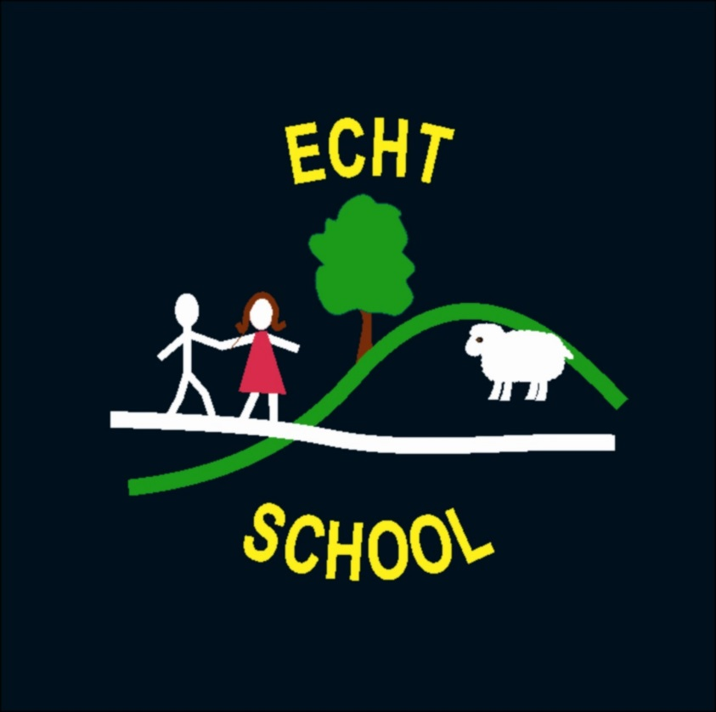

Aberdeenshire Council Education & Children’s Services

“Our vision is for a school in which everyone is able to develop the skills and confidence needed for learning, life and work.”
Echt School

Everyone valued and
Cared for in a
Happy, healthy environment where
Teaching and Learning are fun!

In Echt School our vision is the driving force behind all our improvement activity.

Education & Children’s Service’s Quality Improvement Framework, is the overarching strategic management tool which directs and supports school improvement in establishments across Aberdeenshire. At the heart of the framework is the belief that self evaluation in each school drives improvement and all improvement is aimed at delivering positive outcomes for children and young people.

“Self evaluation is a reflective, professional process through which schools get to know themselves well…Improvement Planning builds on that self knowledge by involving us in understanding and valuing the best of that which already exists, deciding how good we can really be, and identifying the best way forward.
The Journey to Excellence Part 4: Planning for Excellence, HMIe, 2007

Self-evaluation is an on-going process and involves all stakeholders, including our pupils. It is reported annually to parents/carers in our Standards and Quality Report.

Education & Children’s Service Improvement Cycle
Self evaluation to ensure stakeholders commitment
Self evaluation to monitor
and determine progress
Self evaluation to determine impact
Self evaluation to find out
where you have to go

The priorities for improvement contained in the Improvement Plan for 2014 – 15 reflect this process and the priorities identified locally and nationally.

Improvement Priority No. |  |  | 1 | 1 + 2 Languages
Intended Outcome (s) / Impact |  |  |  |  | Actions / Lead member of staff – All staff | Timescales
- Staff training to give staff confidence in delivering this area of the curriculum  - P1-3 will learn French in addition to their native language on a daily basis, in order to understand and use basic everyday language.  - P4-7 will learn French and Spanish in addition to their native language, in order to develop existing language skills to use in everyday contexts. |  |  |  |  | - In-house twilight training with current staff. We will invite Midmar staff to join us if they wish.  - Incorporate into weekly plans to ensure coverage of new vocabulary etc  - Children will share learning with parents via Reports, Showbie, Curriculum Evenings | - 6 month timescale (Jan – June)
How will you measure success?
- Staff discussion
- From talking to the children (in French & Spanish)
- Evidence of work on iPads, class displays etc
- HT monitoring and peer monitoring visits – sharing classroom practice

Progress Check / Comments / Next Steps
Date: | December 2015
Date: | March 2016

Improvement Priority No. |  |  | 2 | Learning for Sustainability
Intended Outcome (s) / Impact |  |  |  |  | Actions/ Lead member of staff – All staff | Timescales
- Gain RRSA Level 1 award (by April 2016) – the work we will do for this will impact positively on the ethos of the school  - Children will continue with Eco Schools work in order to integrate the principles, values and practices of sustainable development into all aspects of their learning.  - Awareness of how children in a different country to ours live – establish link with a school in France  - Making use of our extended outdoor space for learning across all areas of the curriculum |  |  |  |  | - Community group to take a lead on RRSA initiatives in school and guiding work towards Level 1 award  - Continue to extend work on Global Citizenship through Eco Schools and link school  - Create links with mini cluster schools with regards to global citizenship through joint collegiate led by Steve Roberts of the Montgomery Centre  - GLP-S Baseline Whole School Audit  - Establish link with school in France – Kirsty to use contacts to try and find a suitable school  - Embark on joint project with link school  - Continue with good practice already evident in the school | June 2016 and beyond
How will you measure success?
- Link made with French school
- RRSA Level 1 gained
- More effective learning and teaching experiences for children leading to happy and confident pupils
- Feedback from parents on children using their learning in contexts outwith school
Progress Check / Comments / Next Steps
Date: | December 2015
Date: | March 2016

Improvement Priority No. |  |  | 3 | Curriculum Rationale / Design
Intended Outcome (s) / Impact |  |  |  |  | Actions/ Lead member of staff - All staff | Timescales
- Revisit Vision, Values and Aims in order to address the change in the school community since 2010.  - Complete Curriculum Rationale to show whole school community the ‘How, What and Why?’ of Echt School  - Write Frameworks for Expressive Arts, Sciences, Technologies, Social Studies, RME to give teaching staff a structure to work from. |  |  |  |  | - Involve the school community with re-writing the Vision, Values and Aims  - Use Video Scribe on iPad to document our Curriculum Rationale, involving the children in speaking about some elements.  - Ruth to attend course on writing curricular Frameworks and share with staff at Echt and Midmar to write our own. | Ongoing throughout  2015-16
How will you measure success?
- Vision, Values and Aims will be written and shared with school community
- Curriculum Rationale will be written and shared with school and wider community
- Curricular Frameworks will be written and shared within mini cluster where necessary

Progress Check / Comments / Next Steps
Date: | Dec 2015
Date | March 2016

Improvement Priority No. |  |  | 4 | Reporting
Intended Outcome |  |  |  |  | Actions/ Lead member of Staff: All staff | Timescales
- Continue with established process of reporting learners’ progress and achievement to parents/carers.  ie an identified and clear, on-going process with regular information sharing.  - Teaching staff to spend time in other classrooms at their stage in the mini cluster with regard to moderation of learning. This will enable us to make a comparison with our own teaching & learning practice.  - Review and improve our tracking and monitoring of progress across the school in order to ensure smooth transitions from one stage of learning to the next.  - By addressing all of the above, we will see raised attainment and achievement for all pupils. |  |  |  |  | - Continue to use Book Creator termly reports for all school children.  - Continue to engage parents with their children’s reports through the use of digital technology.  - Find a way for P7 pupils to share their reports with S1 guidance staff.  - Engage with mini cluster schools to organise class visits with a view to engaging in moderation conversations.  - Use Stepping Up materials to review and improve tracking and monitoring systems already in place. | By June 2016
How will you measure success?
- Dialogue with learners re their progress and achievement
- Dialogue with parents re improvements in reporting process and their children’s progress and achievement
- Dialogue with staff re improved process

Through
- an audit/survey of parents and pupils at end of reporting year
- an audit/survey of staff – ongoing and at end of reporting year
Progress Check / Comments / Next Steps
Date: | Dec 2015
Date: | March 2016

