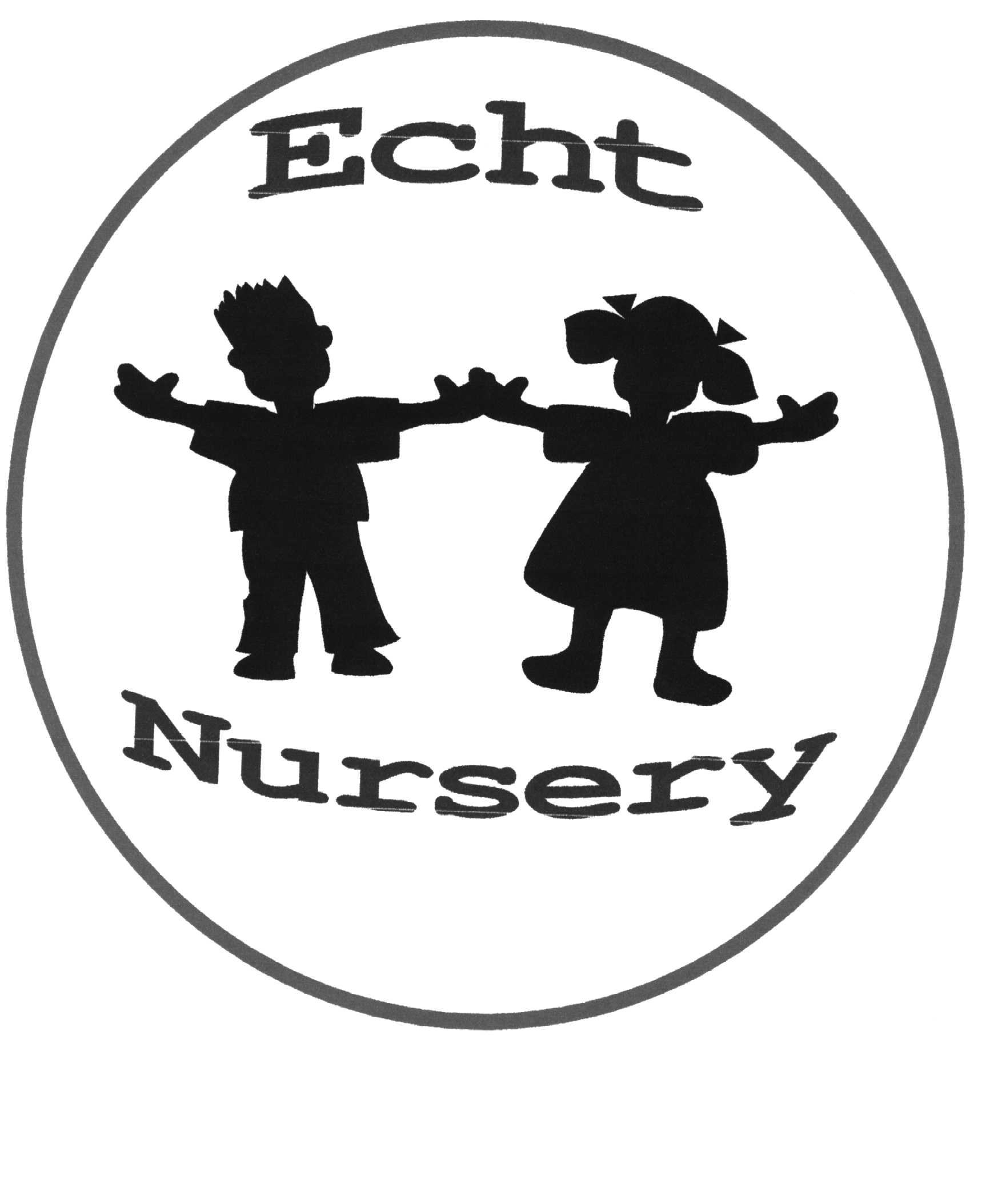


EDUCATION, LEARNING AND LEISURE

HANDBOOK

FOR

Echt Nursery
2010 / 2011
(Updated December 2010)



“Our aims are the building of capacity, the realisation of potential and the achievement of excellence in Aberdeenshire – the very best of Scotland”

Dear Parents and Children,

Welcome to Echt Nursery. The Nursery is located in Echt School. Our nursery opened in August 2000 and caters for children aged 3 to 5.

Research shows that nursery education has a vital role to play for young children. High quality nursery provision provides an important boost for young children before they start primary school. With this in mind we look forward to a rewarding and fulfilling year for us all.

I look forward, as do all other staff and pupils, to meeting you when you come to Echt and I hope your time here will be enjoyable.

Nursery Team

Nursery Teachers - Mrs Janice Geddes and Mrs Diana Robb
Nursery Nurses - Mrs Catherine Walker, Mrs Michelle Greaves and
Michelle Morrison

All enquiries should be addressed to:

Mrs Ruth MacDonald
HeadTeacher
Echt School
Echt
Westhill
Aberdeenshire AB32 6UL

Tel: 01330 860510
e-mail: echt.sch@aberdeenshire.gov.uk

ECHT SCHOOL AIMS

Challenging Learning Experiences

- To engage children and young people in the highest quality and challenging learning experiences

A Caring Environment (Everyone Valued)

- To value and empower our staff, children and young people to promote well-being and respect

An Ethos of Achievement

- To develop a culture of ambition and achievement which focuses on quality experiences and maximises success for all learners

A Shared Vision

- To develop a shared vision for all by promoting fairness, justice and equality of opportunity, involving the whole school community in the life of the school

Partnerships

- To work in partnership with parents, the community of Echt and other agencies in order to meet the needs of every child in Echt School

Leadership

- To encourage a whole school approach to leadership. Responsibility and decision making

Outdoor Environment

- To promote the outdoor environment as a space for learning and encourage everyone to explore, appreciate and respect their world

The Scottish Curriculum

Curriculum for Excellence is now being introduced across Scotland for all 3-18 year olds – wherever they learn. Its purpose is to improve our children’s life chances, to nurture successful learners, confident individuals, effective contributors, and responsible citizens, with the child or young person at the centre of the learning.

In Aberdeenshire our vision and aims for Curriculum for Excellence have been set out in A Curriculum Framework 3-18 for Aberdeenshire. This policy gives clear guidance to schools on the planning and delivery of a more meaningful set of experiences and entitlements that will prepare Aberdeenshire learners for 21st century Scotland, including access to new technologies to support creativity and learning. There will be personal support to help young people fulfil their potential and make the most of their opportunities. All staff have a responsibility to look after our children’s health and wellbeing – to ensure that the school is a place where children feel safe and secure. Across Aberdeenshire schools, communication is being enhanced through the use of Glow (Scotland’s online network). Parents are being supported to use this technology.

Curriculum for Excellence develops skills for learning, life and work to help young people go on to further study, secure work and enjoy life and leisure. It makes learning relevant and helps young people apply lessons to their life beyond the classroom. It links knowledge in one subject area to another, helping children and young people understand the world and make connections. It develops skills so that children can think for themselves, make sound judgements, challenge, enquire and find solutions. Every child is entitled to a broad and deep general education, whatever their level and ability. All staff will be responsible for literacy and numeracy – the language and numbers skills that unlock other subjects and are vital to everyday life.

There will be enhanced ways of assessing progress and ensuring children achieve their potential. There will be new qualifications for literacy and numeracy from 2012/13, and new National 4 and 5 qualifications from 2013/14.

In Echt School we use an interdisciplinary approach to planning from within and across curriculum areas, to provide relevant, challenging and enjoyable learning experiences and stimulating contexts to meet the needs of our pupils. These

incorporate the Outcomes and Experiences of Curriculum for Excellence. This means that topic work may include activities from the curriculum areas:

Expressive arts
Health and wellbeing
Languages including English
Mathematics
Religious and moral education
Sciences
Social studies
Technologies

We aim to continually review, evaluate and improve our curriculum based on the principles for curriculum design:

Challenge and enjoyment
Breadth
Progression
Depth
Personalisation and choice
Coherence
Relevance

Interactive teaching, an active approach and the use of the outdoor environment are key factors in our planning for a rich and rewarding learning environment.

NURSERY CURRICULUM

Curriculum for Excellence

Your children are working within the early level of Curriculum for
Excellence.

In Echt Nursery we plan for:

• opportunities for children to learn through purposeful, well planned
play
• quality, breadth and depth of learning experiences that children
will encounter and how we can work together to ensure that every child can achieve and attain their potential.
• active, experiential learning in natural and real contexts, familiar to children and appropriate to their interests and stages of development
• positive interaction with adults and other children and through play and active exploration of their environment
• learning and teaching across curriculum subjects and areas are integrated to develop their understanding of, for example, science, language, communication, technology and mathematics from an everyday experience, such as water or sand play
• smooth transitions and collaborative working with Primary 1

More information about the Curriculum is contained in our Nursery Policies which you may read on request.

Some Questions Answered

What are the Nursery times?

Morning session: 0900 – 11.30a.m.

Afternoon session: 12.45 - 3.15p.m.

Arrangements for arrival are flexible. We ask that each child be brought by you or by another adult (16 years or over). Please let us know if someone other than yourself will be collecting your child.

We like parents to feel welcome to come into Nursery. We open the classroom door for the last 15 minutes of each session to enable you to come in and join in with the singing or story-time.

Access to Nursery is at the rear of the building and a secure entry system is in place. The outer door will be open to allow access to shelter. The inner door is locked at all times except during the 15 minute flexible drop off periods. i.e. morning session door unlocked from 09.00 - 09.15 a.m. (for delivering your child to Nursery) and 11.15 – 11.30 a.m. (for collecting your child from Nursery). Afternoon session door unlocked from 12.45 – 1.00 p.m. (for delivering your child to Nursery) and 3.00 to 3.15 p.m. (for collecting your child from Nursery).

Who will the children meet at Nursery?
The Nursery teachers are Mrs J Geddes and Mrs D Robb. Mrs C Walker, and Mrs M Greaves are the Nursery Nurses and Mrs M Morrison the relief Nursery Nurse. Other visitors to Nursery will include other members of staff and children from Echt School. Sometimes there will be a student on nursery placement. They, and you, will also meet other parents and certain visitors we may have in school.

INDUCTION TO NURSERY

Why do the children start in small groups?
Your child will be introduced to nursery over the first few weeks of the school session. This gradual phasing in enables the staff to spend time with each new child and allows children to familiarise themselves with the Nursery and its routines.

What will my child do at Nursery?
In Nursery, we build on learning which has already taken place at home and playgroup and lay the foundations for the educational experiences to be provided in P1.

We provide a secure and happy environment where children learn through play. Play activities are carefully planned to stimulate curiosity, to encourage language development and to foster a range of intellectual and physical skills.

We are concerned with developing social skills such as making friends, sharing toys, equipment and adults’ time, playing and working together and communicating with adults and other children.

When can I find out about my child’s progress in Nursery?
At the start of each nursery session there is always a member of the Nursery staff available to speak to you.

Each child has a profile to record their achievements and progress. This profile includes information about assessments and observations carried out throughout the year. You are welcome to read your child’s profile anytime. There is a comments page for you to add any comments or concerns.

We have an open evening in October. This is an opportunity for you to find out about some of the activities your child will experience at Nursery. There will be Open Sessions timetabled in June. Parents will be invited to come in and join in with their child’s Nursery session.

You can also make an appointment at any time to speak to the nursery staff by contacting Mrs Ruth MacDonald, Head Teacher.

What do I pay?

Free Nursery Places
Every child in their Pre-school and Ante-pre school year is entitled to a place either at a Local Authority Nursery class or at a Partnership Playgroup.

Snack
The cost of snack is 30p per session making a total of £1.50 per week. Snack is an important part of the nursery experience and we aim to provide the children with a healthy variety of food whilst encouraging them to try different things. It is also an opportunity to reinforce the sharing and turn taking skills already established in nursery whilst also being a sociable time for the children.

We have a piggy bank - please feel free to make donations
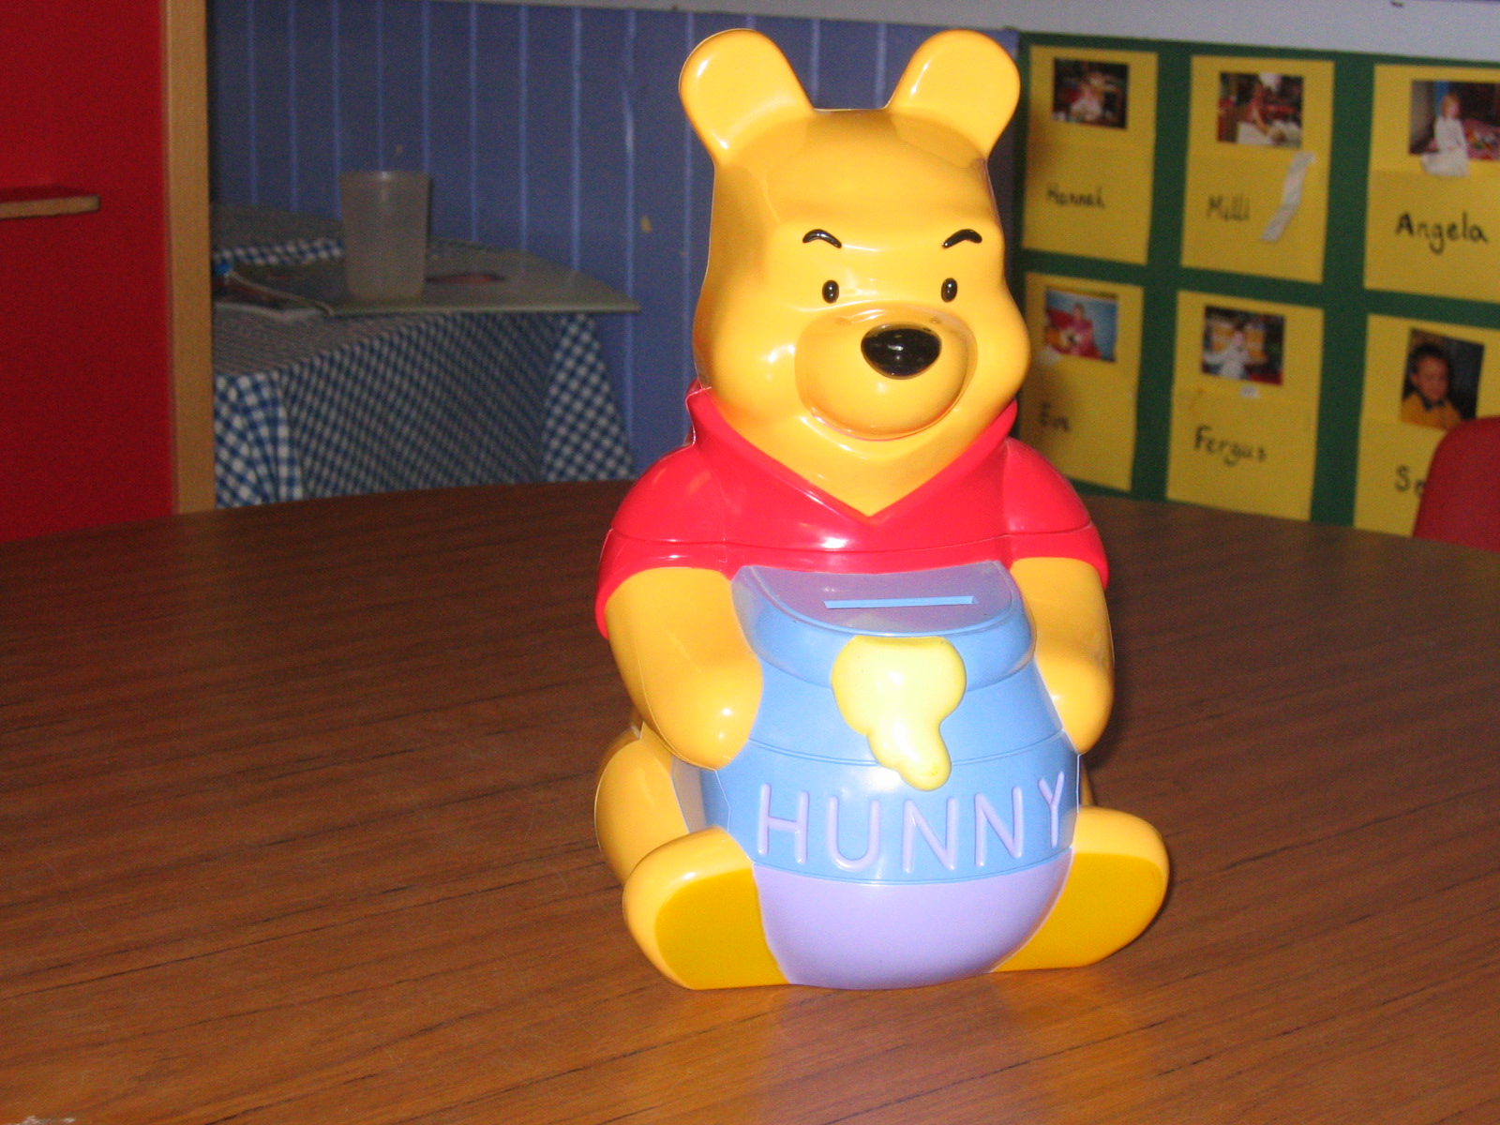
which will be used to buy extras for the nursery.

Fund Raising
From time to time a fund raising activity will be organised and all money raised will be spent on materials and equipment for the nursery. The nursery committee is usually involved in organising fund raising events.

Commitment
To benefit fully from the nursery experience, it is vital that attendance is regular. If your child is unwell or unable to attend a session for any reason, please inform the school office that day.

Partnership
We invite parents to come and help during nursery sessions.

The informal chatting between staff and parents at the start and end of the Nursery day is very valuable for the sharing of information.

If you require to speak to staff about a private matter please inform the Head Teacher and an appointment will be made at a time convenient to both parents and staff.

What does my child need for Nursery?

Clothes should be comfortable and suitable for active learning. A change of shoes for indoors is necessary for when we go outside on wet days – children change into these when they arrive at Nursery. As we go outside every day, come rain or shine, we would appreciate if your child could bring wellies and waterproofs to Nursery each day. Waterproofs may be left all week if you wish and can be taken home after the Friday session.

Your child will need to bring a change of clothes at the beginning of term in case of “accidents”. We will keep the clothes in Nursery in labelled bags. Your child will need a pair of gym shoes for wearing in the gym hall. The children will also require a pair of shorts and a tee shirt for gym. Please bring these daily. Overalls are supplied for painting and water play.

The nursery has its own sweatshirt with the nursery logo on the front. If you would like to purchase one, please complete the enclosed order form and return in the 1st week of term. Please make cheques payable to Echt Nursery.
Please label your child’s gym shoes, tee shirt, shorts and sweatshirt.

Illness

If your child is feeling unwell please keep him / her at home. If your child has had vomiting and/or diarrhoea, please keep them at home for 48 hours after the last episode.

What happens if my child becomes ill while at nursery?
We will contact you if your child becomes ill at nursery.

Please give us the name, address and telephone number of someone who will care for your child if you are not available. This person must be able to collect your child if you are unable to.

Please inform nursery staff of any special circumstances relating to your child’s health e.g allergies, asthma etc.

What happens if my child is absent from Nursery?
If your child is going to be absent for any reason please inform us by telephoning the school or sending a message with another parent.

Family Holidays During Term Time
Please note that children taking time off to accompany their parents on holiday during term time is not a legal right.

However it is acceptable under exceptional circumstances for schools to authorise a family holiday during term time. They include:

- A family holiday judged to be important to the wellbeing and cohesion of the family following serious illness, bereavement or other traumatic events.
- Parental difficulty obtaining leave where an employer cannot accommodate leave during school holidays.

Do the children ever go on outings?
The children go on short, local visits from time to time when there are links with the environment and themes being developed in nursery. Please complete the parental consent form at end of booklet.

We also arrange visits to school from specialist organisations i.e. Police, Road Safety etc. when they are relevant our themes.

Do I have to transport my child to nursery?
It is your responsibility to transport your own child to and from nursery. If alternative arrangements are made, please inform nursery staff as well as your child of any changes. Children must be collected from nursery by an adult (16 years of age or older).

Where can I park at school?
Nursery parents may park in the school car park when there are available spaces. In order to ensure children’s safety, please remember to reverse park into parking spaces at all times in the school car park. There is also some parking space in the Echt Hall Car Park.
Gates into the playground from the car park and the pavement must be locked at all times. Please keep these accesse routes clear.

What happens if the school has to close?
If the school is to close early for any reason you will be contacted by telephone. If this is not possible, then the school will contact the named ‘emergency contact’ provided by you for this purpose. No child will leave school without contact having been made.

Storm Arrangements
We follow the Adverse Weather Procedures introduced by Aberdeenshire Council. In all but the most exceptional circumstances the school will be open. Any decision to close the school rests entirely with the Head Teacher Should school not be opening, an announcement will be broadcast on NECR and Northsound Radio. You can also obtain information by phoning the Emergency Information Service on 0870 054 4999 and input Echt School PIN no. 021650. Information is also available on Aberdeenshire Council’s website www.aberdeenshire.gov.uk

Please use the following considerations if you are in doubt whether your child should attend nursery in inclement weather: -

- Do not send your child to school if you consider the weather to be bad or likely to cause the return journey to be difficult.
- If, on the grounds of safety, you decide not to send your child, every effort should be made to inform the school of this.

Please inform us of any change of address or telephone number and keep us up to date with emergency contacts.

Can my child bring toys to Nursery?
Young children often need to bring something with them to Nursery to maintain a link with home, whether it is a teddy or a toy. This can be brought in to Nursery and will be put somewhere safe, out of reach of the other children but within view of your child. Also, your child may have something exciting to show his/her Nursery friends. If your child wishes to bring something with him/her to a Nursery session, we will take every possible precaution to look after whatever is brought in but cannot take responsibility if an accident occurs.

What happens if my child needs to go to the toilet?
Your child will always be taken to the toilet by a member of the Nursery staff during the nursery session. If you child requires the toilet when they arrive prior to the Nursery session please accompany them yourself. The toilets are situated next to the main entrance into school. Please advise Nursery staff on admission if your child requires help with toileting.

School Pupil’s Insurance
The position is as follows:
“No insurance cover is held by the Council to provide automatic compensation to pupils in the event of a personal accident or death. It is your responsibility as a parent to insure your child for personal accident or death if you feel this is appropriate.

The Council does hold third party liability insurance which indemnifies the Council for claims from third parties (e.g. parents of pupils) who have suffered injury, illness, loss or damage arising from the negligence of the Council or its employees. However, if there is no negligence, no claim would be accepted by the Council”.

This information is brought to your attention at this time in order that you may take whatever action you feel appropriate. I am also anxious to avoid the potentially distressing situation of parents only becoming aware of the insurance position after an accident has occurred, however remote the possibility.

CHILD PROTECTION
"Everyone has a responsibility to protect children from harm. School staff are in a unique position to contribute towards the protection of children and must share concerns with appropriate colleagues and agencies.

Every school has a designated officer who has been specially trained to listen to concerns and act on them as necessary.

Unless satisfied that a child has not been harmed or is not at risk of being harmed, the school must relay their concerns immediately to the social work service and / or the police.

Social work and the police will determine when and how the child’s parents/carers and other services are to be informed of the concerns.”

Local Social Work Office: 01467 625555

Supporting Pupils with Medical Needs
The Authority has introduced a policy with regard to Supporting Pupils with Medical Needs which sets out clear guidelines for the administration of medicine to protect both staff and Pupils.

Parents are responsible for supplying information about medicines which their child needs to take at school, and for letting the school know of any changes to the prescription or the support needed. The parent or doctor should provide written instructions as detailed in Form 1. It should be noted that no medication can be administered by the school to a pupil under 16 without the parents’ written consent. It is important that parents be aware of the following points:

i) Children who are feeling ill should not be sent to school.

ii) There is no legal duty which requires school staff to administer medication; this is a voluntary role. Therefore, whenever possible, arrangements should be made for prescribed medicine to be administered by the parent during school hours or to be prescribed, frequencies which enable it to be taken outside school hours. This will reduce the need for forms being completed timeously and also to avoid storage of medicines in schools.

iii) It is a parental responsibility to inform the school of their child's medical needs. It is important for the school to have sufficient information about a medical condition of any pupil with long term medical needs. The information will be shared with staff on a need to know basis, in the best interests of the child.

iv) It is good practice to allow pupils who can be trusted to do so to manage their own medication e.g. inhalers from a relatively early age. If pupils can take their medication themselves, staff may only need to supervise this or remind them.

The school's procedure with regard to the implementation of the Authority's policy will indicate whether pupils can carry and administer their own medication, bearing in mind the safety of other pupils and the security of the medication.

Form 4 of the policy should be completed by parents who wish their children to carry their own medication.

v) School staff should generally not give non-prescribed medicines to pupils. Non-prescribed medicines (e.g. throat lozenges) should be taken with the permission of the class teacher.

If you have any concerns regarding the above, they should be addressed directly to the Head Teacher.

ECHT SCHOOL COMMENTS/COMPLIMENTS/COMPLAINTS POLICY

We are committed to delivering a quality service to all our users. We aim to take effective action to ensure standards are upheld and welcome being informed where they have not been satisfactory.
We believe a comments/compliments/complaints procedure can contribute to the quality and effectiveness of the service. This policy statement sets out a procedure for parents and carers to complain about any aspect of the service. Complaints should be made constructively and every effort will be made to resolve them at an early stage. It is in the best interests of parents, carers, children and staff that complaints are dealt with fairly and confidentially.

- At Echt School we shall respond to the comments or complaints of all parties as promptly and positively as possible.
- In the first instance the complainant should contact the school / nursery staff for informal feedback. This may be all that is required to resolve the problem.
- Persons making a complaint may be supported by a friend, relative or representative at different stages of the procedure.
- If the problem remains unresolved, the complainant should contact the Head Teacher either by letter, telephone or in person. The Head Teacher is not always immediately available, but the school administrator will be happy to make an appointment at a suitable time.
- The Head Teacher will listen to the complaint and investigate the circumstances surrounding it.
- The Head Teacher will then report back to the complainant and try to resolve the problem.
- If the complaint cannot be resolved at school level, the complainant or the Head Teacher may contact the Senior Education Officer at the Education Offices, Queens Road, Stonehaven.
- Complaints will be acknowledged within 5 working days. Please allow 28 working days to investigate a complaint.

- A record of complaints is kept in school. It may be shared with Aberdeenshire Council officials or officers of the Care Commission. Otherwise it is confidential.
- Should parents wish to contact the Care Commission direct they may call 01224 793870.
- This procedure is displayed in the school / nursery noticeboards for the information of parents and visitors.

We comply with Aberdeenshire Council’s “Procedure for Council Employees” on Comments Compliments and Complaints. Copies of this policy are available from the local library or www.aberdeenshire.gov.uk

