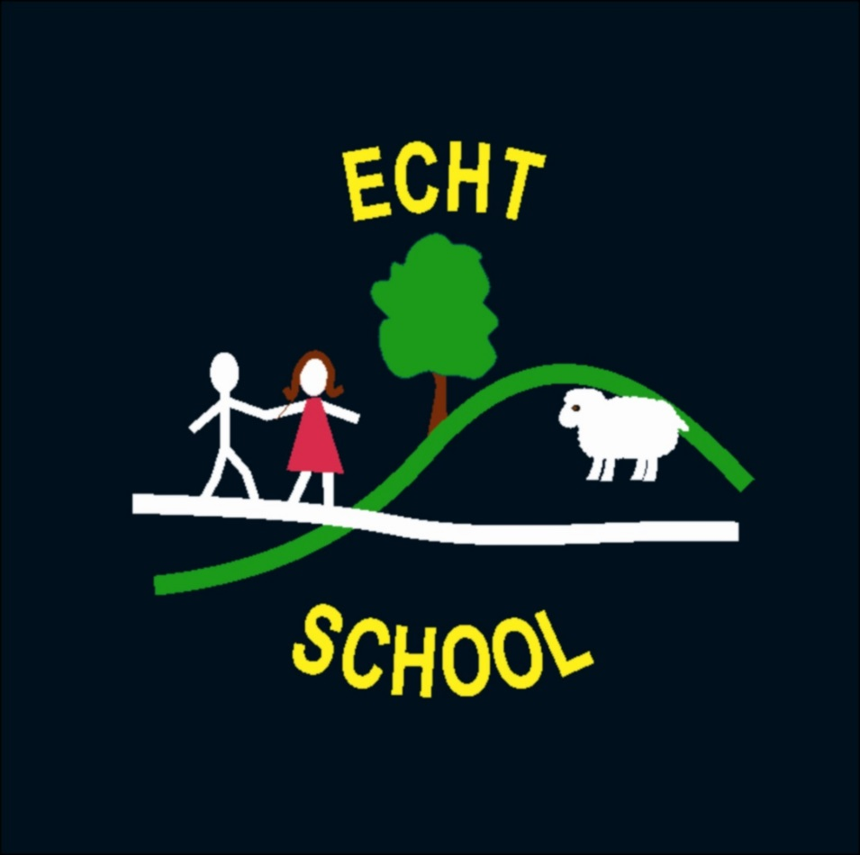

Child
Protection
Policy

Child Protection Policy

Revision No. | Details of Change | Date
1 | Full review of procedures | March 2012
2 | Policy Update | March 2015
3 | Policy Update | March 2018

All children have a right not to be abused and to be protected from abuse and neglect, therefore child protection is the responsibility of everyone. ‘It’s everyone’s job to make sure I’m alright’ (Scottish Executive, Nov 2002) underlines the need for us all to take responsibility in order to protect children.
In our school we are committed to creating an environment in which children are safe from abuse and in which any suspicion of abuse is responded to promptly and appropriately. The well being of children in our care takes precedence over any other consideration.
In order to achieve this we will:
- Seek to work in partnership with parents, carers, other agencies and Aberdeenshire Council to promote good practice in the area of child protection
- Update any changes in child protection policy and practice under the guidance from the designated person in the school
- Endeavour to ensure that all staff have access to appropriate child protection training, supervision and support in order to implement this policy effectively
Child abuse is a criminal offence. All staff working in our school have a duty to report any reasonable concern that a child may be being abused.
The role of members of staff is to inform the designated person of any instance, which suggests that abuse is taking place. It is not the role of the member of staff to wait for proof, investigate or gather evidence of abuse.
When a child tells an adult about possible abuse, his or her statements should not be dismissed or ignored. The adult should attend carefully to what the child wants to communicate, taking account of the child’s age and stage of development, and allow the child to say what he or she wants to say without being drawn into detailed questioning.
What constitutes child abuse?
Categories of abuse are
- Physical injury
- Non-organic failure to thrive
- Emotional abuse/neglect
- Sexual abuse
- Physical neglect
More details of categories of abuse can be found on the NESCPC website: http://www.nescpc.org.uk/ChildProtection/CategoriesOfAbuse.asp .
Members of staff reporting suspected abuse, or any incident causing concerns should make a written note as soon possible following the disclosure/observation, noting the actual words spoken by the child.
This should be signed and dated and given to the Head Teacher.

A confidential log of all incidents causing concern is kept in the HT office.
Our school will always seek to work with families in a clear, positive and open way, bearing in mind always that the welfare of the children is paramount.

In our school the designated person is:
MRS RUTH MACDONALD
In her absence the deputy is:
MISS SHANNON REID
REMEMBER:
Any concerns about the well-being of a child need to be shared.
No matter how good we are at evaluating and assessing matters to do with children in our classes, when it comes to the child’s welfare we cannot evaluate and assess potential danger, risk, damage, as we only know a tiny part of the whole picture. We must share our concerns with the designated person.

Child Protection Procedure checklist for our staff.
If
- a child discloses abuse, or
- a member of staff suspects a child may have been abused, or
- a third party expresses concern
- a staff member witnesses an abusive situation involving another staff member
the member of staff must: RECORD and REPORT

R Respond without showing any signs of disquiet, anxiety or shock
E Enquire casually about how an injury was sustained or why a child appears upset
C Confidentiality must not be promised to children or adults in this situation
O Observe carefully the demeanour or behaviour of the child
R Record in detail what has been seen and heard
D Do not interrogate or enter into detailed investigations: rather encourage the
child to say what he/she wants until enough information is gained to decide whether or not a referral is appropriate
Then REPORT to the designated person without delay. Members of staff must not
- Investigate suspected/alleged abuse themselves
- Evaluate the grounds for concern
- Seek or wait for proof
- Discuss the matter with anyone other than the designated child protection person/depute. (If neither of these is available in school in an emergency contact the Head Teacher by mobile phone.)
This policy is available on Glow and is followed by all members of the teaching and non-teaching staff of Echt School. It is also available to parents.
This policy links in with the school policy on E-Safety.
More information about Child Protection can be found on the NESCPC website:
http://www.nescpc.org.uk/home/home.asp This is the best place to find information as it is updated regularly. Aberdeenshire Council information is on the Aberdeenshire Council website: http://www.aberdeenshire.gov.uk/care/help/protection/childprotection.asp and on Glow: https://portal.glowscotland.org.uk/establishments/aberdeenshirecouncil/Child%20Protection /default.aspx

Contact details: Social Work Office Gordon House Blackhall Road Inverurie
AB51 3WA
Tel: 01467 620981

R

