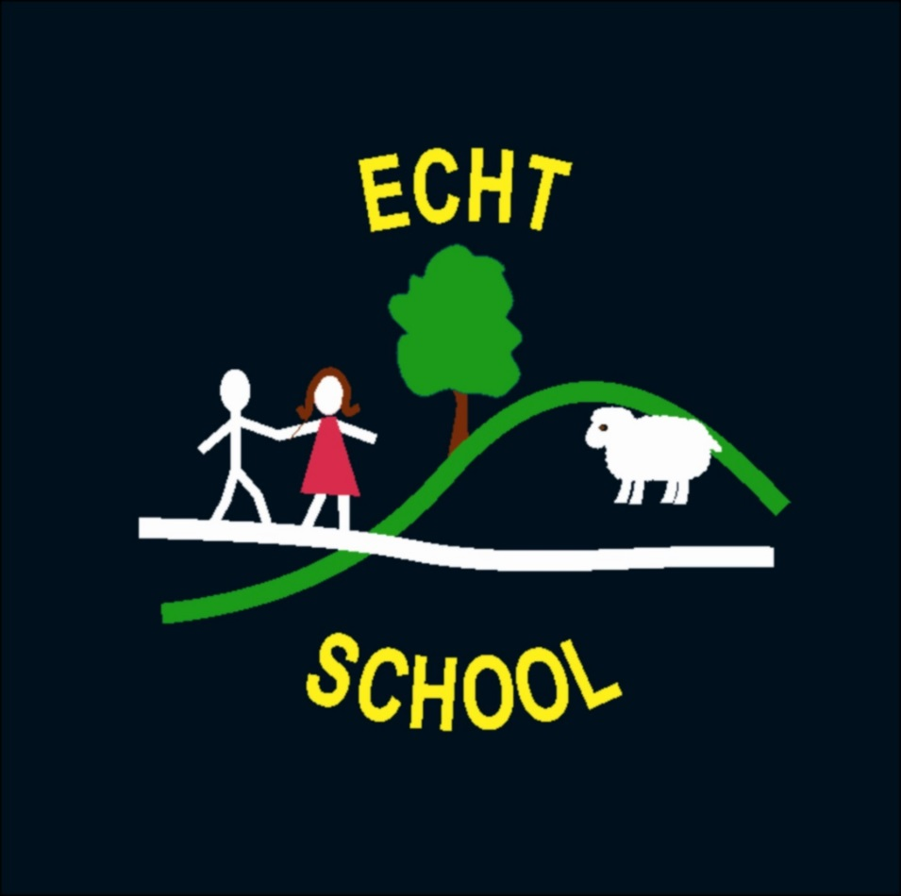

Data Protection
Policy

Data Protection Policy

Revision No. | Details of Change | Date
1 | Full review of procedures | December 2017
2 | Policy Update | December 2020

To be read alongside Aberdeenshire Council’s policy and code of Practice.

Rationale

As employees of Aberdeenshire Council, all staff at Echt School follow Aberdeenshire’s policy and code of practice for Data Protection. This ensures that all employees adhere to the Data Protection Act of 1998. Furthermore, in accordance with article 16 of the UN Convention for the Rights of the Child, every child has the right to privacy. The law should protect the child’s private, family and home life.

Arrangements at Echt School
- All new staff must complete the Data Protection awareness course available via the Aberdeenshire Learning and Development Online (ALDO) portal.
- All existing Staff must ensure that they remain aware of the principles of Aberdeenshire policy either by revisiting the ALDO course or reading the policy available on the Staff Drive or on Arcadia.
- All staff must ensure that they follow the principles of Data Protection outlined in Aberdeenshire’s policy when using computers, cameras and when using flash drives.
- Confidential pupil information will be stored securely, in locked cabinets.

Staff Data

Transferring data about school staff

The Scottish Government and its partners collect and use information about school staff to help improve education across Scotland. The sections following explain why we need this information, how we use it and what we do to protect the information supplied to us.

Why do we need your data?

In order to make the best decisions about how to improve our education service, Scottish Government, Education Authorities and other partners such as Education Scotland, GTC Scotland and teaching unions need accurate, up-to-date data about our teachers. In particular individual level staff data is vital for use by Scottish Government in education workforce planning. As a consequence of receiving this information, Scottish Government will be better able to:

- Plan more accurately the number of staff to be trained each year,
- Identify shortages in particular sectors and subjects
- Monitor movements in and out of the profession at a national level.
- Better understand the factors affecting education
- Share good practice

Data Policy

Information about school staff is collected through our statistical surveys in partnership between Scottish Government and Local Authorities through the ScotXed programme which aims to help schools and Local Authorities by supporting efficient collection, processing a dissemination of statistical information. The Scottish Government then provides analysis of the data to support research, planning, management and monitoring of education services as well as to produce National Statistics publications.

Education data within Scottish Education is managed effectively by secure systems and is exploited as a valuable corporate resource, subject to confidentiality restraints. Scottish Government will make publicly available any information that allows individual members of staff to be identified, nor will data be used Scottish Government to take action in respect of individuals. No information on individual members of staff can or would be published by Scottish Government. Providing sensitive information such as national identity and ethnic background data is entirely voluntary. The staff census is supported by teachers unions who helped draw up the list of data collected.

The individual data collected by Scottish Government is used is used for statistical and research purposes only.

Your data protection rights
The collection, transfer, processing and sharing of ScotXed data is done in accordance with the Data Protection Act (1998), the National Statistics Code of Practice requirements and other legislation relate to safeguarding the confidentiality of data relating to individuals. The Data Protection Act gives you the right to know how you will use data. Fuller details of the uses of staff data, including the published data, can be found on the ScotXed website: www.scotxed.net

Scottish Government works with a range of partners including HM Inspectorate of Education, GTC Scotland and the SQA. On occasion, in order to meet our aim of improving our education system, we many make individual data available to partners and academic institutions and organisations to carry out additional research and statistical analysis to meet their own official responsibilities. Any sharing of data will be done under the strict control of the Scottish Government, and will be consistent with our data policy. This will ensure that no individual level data will be made public as a result of the data sharing and that this data will not be used to take any actions in respect of an individual. Decisions on the sharing of data will be taken in consultation with relevant colleagues and individuals within and outwith Scottish Government. At all times individual’s rights under the Data Protection Act and other relevant legislation will be ensured.

Concerns
If you have any concerns about the ScotXed data collections you can email the Senior Statistician, Peter Whitehouse, at Peter.Whitehouse@Scotland.gsi.gov.uk or write to The ScotXed Support Office, Area 1B, Victoria Quay, Leith, EH6 6QQ. Alternative versions of this page are available, on request from the ScotXed Support Office, in other languages, audio tape, Braile and large print.

