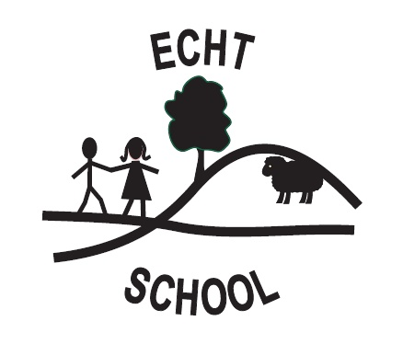
ECHT NURSERY
INFECTION CONTROL POLICY

Crossroads nursery has a duty of care to protect the health, safety and welfare of all users and employees. In addition to this the prevention and control of infection is essential in helping to establish a safe , healthy and secure environment in which children can learn and develop through play. We take measures to prevent and minimize the spread of infection in our establishment.
To help achieve this we work in partnership with parents and carers, we will adhere to the following practices in line with current guidelines.
General – Re: Infection control
- Inform all staff, visitors and students of the existing policy and procedures.
- Include visual instructions if possible.
Ensure
- adults and children have separate toilet facilities.
- nursery staff have Food Hygiene Certificate or other food-handling training.
- dedicated sinks are strictly utilised by adults and children

- Staff will be vigilant as to signs of infection recurring.
- Parents informed that children should remain at home if suffering from infection and nursery should be informed of nature of infection.
- Parents reminded that children may not return to nursery until 48 hours after vomiting or diarrhoea has ceased.
(For other infections see Appendix 1 for information and exclusion period.)
Hand Hygiene – Children and adults should wash their hands
- Before eating or handling food or drink.
- After using the toilet, potty or changing a nappy
- After contact with contaminated surfaces (rubbish bins etc)
- When returning to nursery after outdoor activities

Respiratory Hygiene
- Cover mouth and nose when coughing or sneezing
- Dispose of tissues hygienically
- Encourage children to wash their hand after coughing /sneezing

Personal Protective Equipment (PPE)
PPE includes the use of single use disposable gloves and single use disposable aprons
- Nappy changing – disposable gloves
- Nose bleeds/ body fluids –disposable gloves and disposable apron
- Possible contact with blood or body fluids from cleaning toys or equipment – disposable gloves or household cleaning glove

Environmental and Kitchen Cleanliness
- Clean and disinfect food storage areas
- Clean and disinfect food preparation areas
- Clean and disinfect snack table
- Store food that require refrigeration, covered and dated within a refrigerator, at a temperature of 5°C or below.
- Only food bought from a reputable source will be consumed.
- Sell by dates will be rigorously adhered to

Spillages
- All staff trained in how to safely clean up spillages of blood and body fluids
Equipment
- There must be a hand wash basin with warm running water, liquid soap and disposable paper towels in all toilets and areas where nappies are changed.
- Areas where nappies are changed or potties are used must be separate from where food is prepared or eaten, and where children play. At Echt we have a designated Changing area (See Toileting policy).
- All toys and equipment must be safe for use, well maintained and where possible, can be easily cleaned.

Toilet
Most children will be well able, on entry to pre-school, to use the toilet by themselves. Nevertheless they are still very young and teachers should be aware of the necessity of:
- Supervision – children may require help within the toilet area
- Size of toilet - where adults size toilets are used, a suitable “toilet step” will be provided for small children.
- All children keep spare clothing for any emergencies, whether toileting or during play activities.
- Close contact will be kept with parents to assist their child with any difficulties or concerns. If accidents become more frequent and where persistent difficulties occur it may be that other agencies need to be alerted and offer support to the family.
- If a child has not been toilet trained at all prior to admission to the establishment, outside agencies may become involved to support the family in establishing toilet training procedures

Nappy Hygiene/ Changing
A Nappy Changing Policy (Children’s Toilet Hygiene and Nappy Changing) is in place for Echt. With regard to infection control the following will be adhered to
Ensure there is
- a clean waterproof changing mat (do not use if torn or broken)
- A clean nappy (disposable or non-disposable)
- Water-based disposable wipes, or soap and water and disposable wipes
- The child’s own tub or tube of barrier cream. Do not use shared tubs or tubes of barrier cream
- A plastic bag (or nappy sack) for the used nappy
- PPE for staff — a single-use disposable plastic apron and disposable gloves (on both hands)

