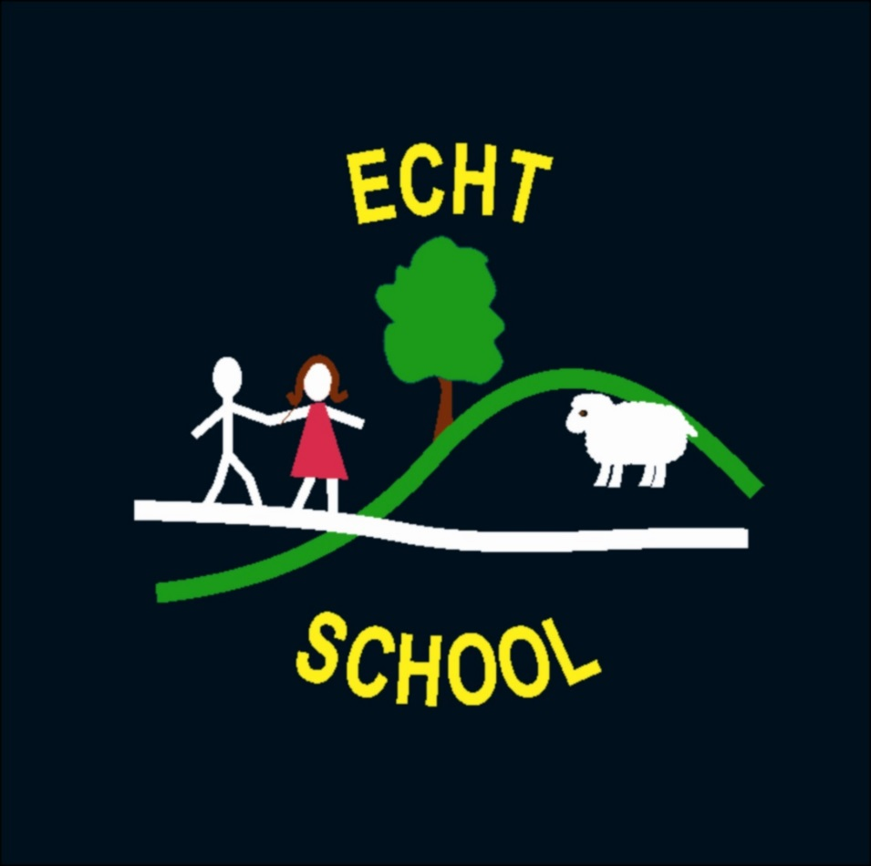

Outdoor Learning
Policy

Social Media Policy

Revision No. | Details of Change | Date
1 | Full review of procedures | December 2017
2 | Policy Update | December 2020

The journey through education for any child in Scotland must include opportunities for a series of planned, quality outdoor learning experiences. Curriculum for Excellence offers opportunities for all children and young people to enjoy first-hand experience outdoors, whether within the school grounds, in urban greenspaces, in Scotland’s countryside or in wilder environments
Such experiences inspire passion, motivating our children and young people to become successful learners and to develop as healthy, confident, enterprising and responsible citizens.
(LTS Curriculum for Excellence Through Outdoor Learning 2010)
Rationale
The outdoors can provide space and freedom for a type of learning that is difficult to replicate indoors. All children and young people have the right to experience the unique and special nature of being outdoors. We feel it is important to enable children to use the outside environment as a context for learning throughout the year. Children and young people will have the opportunity to learn in, about and through the full range of environments in Aberdeenshire – physical, historical and built.
Purposes
- To raise the profile of outdoor learning
- To encourage close links with parents and the school in celebrating our outdoor space and the rich learning that can take place within it
- To empower children and young people to take ownership of their learning, allowing their minds and bodies to thrive
- To provide a safe and secure environment
- To encourage children and young people to care for their environment

Learning and Teaching
- Ensure that children enjoy energetic activity outdoors and the feeling of wellbeing that it brings, including opportunities to develop their large motor skills
- Plan for outdoor learning with the children to offer experiences which have meaning to them and which are led by the child
- Ensure that our outdoor area and resources within it are flexible and versatile, where children can choose, create, change and be in charge of their play environment
- Ensure that the outdoor space harnesses the special nature of the outdoors, to offer children what the indoors cannot. This should be the focus for outdoor provision, complementing and extending provision indoors
- Children should access the outside area as much as possible, throughout the seasons
- Possibilities for outdoor learning will be considered throughout planning, using it as a context and a natural resource for learning

Support for Pupils
- Observe, assess and record outdoor learning, ensuring that there is adequate provision for children to extend their learning
- Enable children to work both individually and co-operatively outside
- Support inclusion and meet the needs of individuals, offering a diverse range of play-based experiences
Ethos
- Help children to take responsibility and care for the outside environment and resources within it
- Encourage children to respect their environment and to care for living things
- Work together (children, staff, parents, community) to create a better environment for all
- Enable children to appreciate the beauty of nature; encouraging children to use a variety of natural resources
- Give children the opportunity to find a quiet space to relax
- Encourage children to enjoy and have fun outdoors in many contexts

- We will support children in taking risks within a safe and secure environment
- It is important to ensure that the outdoor environment offers challenges and teaches the children how to be safe and aware of others
- Outdoor learning opportunities will be grasped when available and staff and children will analyse the risk
- A Benefit Risk Analysis will be carried out where appropriate
Monitoring and Evaluation
- Assessment of the children’s learning should be valued equally indoors and outdoors
- Outdoor learning should be monitored as part of performance management
- This policy will be evaluated and reviewed biannually
Resources
- Organise and/or provide necessary resources, ensuring that the children wear suitable clothing depending on the weather
- Develop a set of rules through discussion with children
- Enable children to use resources safely and to manage and use the space and freedom responsibly

