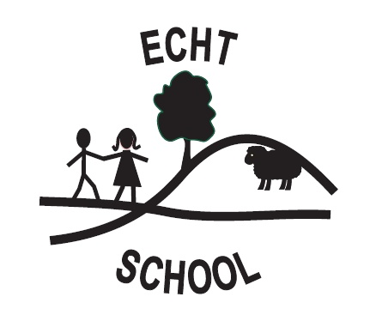

ECHT NURSERY OUTDOOR PLAY POLICY
We value outdoor play as an intrinsic part of the curriculum. By ensuring outdoor play is an integral part of the nursery routine we consciously seek to transmit a positive attitude to the outdoors and enrich the child’s understanding of the world around him/her

- We aim to provide a safe and secure, yet stimulating environment for all children to explore, engage and learn in the outdoor area.
- We aim to provide experiences that will enable all children to progress in all aspects of Curriculum for Excellence – Early Level.
- We aim to ensure that all staff understand the value of outdoor play and so are enthusiastic and active in their approach to learning outside.
- Appropriate activities will be planned for the children which will come from their interests. This will ensure the outdoor environment is not only ensuring all children’s needs are being met but it provides a learning and stimulating environment which is of high quality.

Active learning experiences outdoors are essential for young children. They give children opportunities to practice their developing skills, make them feel good and to explore their world. It is also important for children’s physical, mental and emotional development. We believe that children should begin to take risks and face challenges outdoors

- The outdoor area will be resourced and available for the children to access on a daily basis.
- Children will be able to choose to use the outdoor area freely during free play, and focus activities may be planned for outdoors at a fixed time of the day
- The resources provided will support learning across the Early Level.
- Planning will reflect individual interests, develop group work and thematic play
- The children will be given simple rules for the outdoor area to promote a safe and secure environment.
- Staff will act as positive role models and facilitator of children’s learning.
- Staff will be pro-active and get involved with the children’s learning to ensure all children are getting the most out of their learning environment.
- Equality of play opportunities will be promoted by all adults supporting outdoor sessions.
- Children will need to have appropriate outdoor clothing for the weather in order to enable them to fully access the activities outside. This will include, but are not restricted to:

*Waterproof coat *Footwear appropriate for playing out in
*Warm coat with hat, scarf & gloves *Sun protection cream and a hat

We believe that access to the outdoor area is beneficial to the health and well-being of young children.
Whenever children are using the outdoor area we will ensure it is appropriately staffed.
Staff will make observations to inform future planning when working with children in the outdoor area.

