Echt Nursery
Handbook

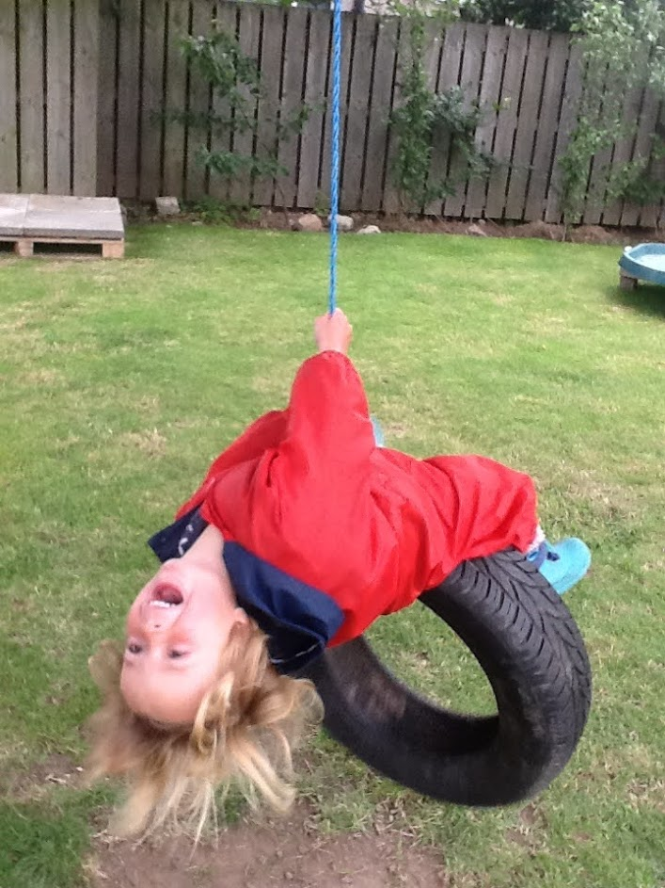

EVERYONE INCLUDED, RESPECTED AND RESPONSIBLE
CREATIVE AND CURIOUS, INDEPENDENT LEARNERS
HAPPY AND HEALTHY, WE BELIEVE IN OURSELVES
TOGETHER WE GROW, ACHIEVING SUCCESS
Contents

2) Contents
3) Session times
4) Our nursery team
5) Our early years environment and philosophy
7) Curriculum for excellence – early level
9) Nursery snack
10) Nursery lunch
11) Home and nursery partnership
12) My key worker and “All About Me”
13) My learning journal, belongings, and nursery uniform.
14) Safety, security, and health matters
15) Starting nursery, attendance, data protection and insurance
16) Child Protection, comments, compliments, and complaints

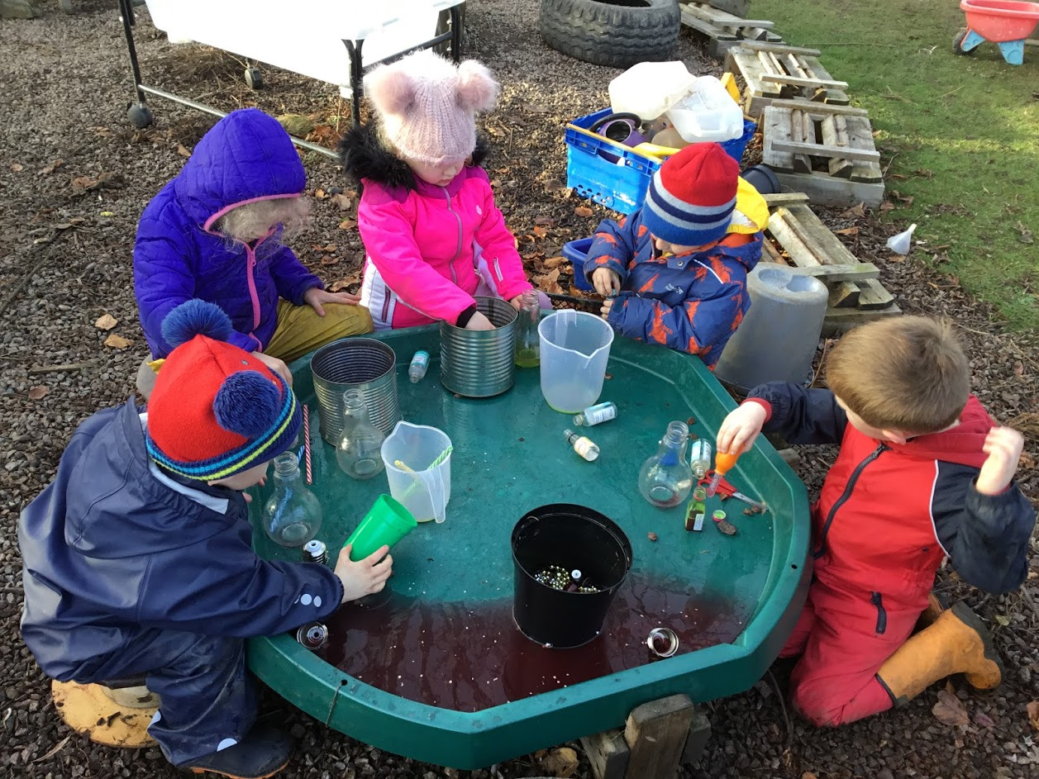

Session Times

Echt nursery is registered with the Care Inspectorate as providing accommodation for twenty-four children per session. Following Scottish government policy, from August 2021, we are able to offer 1140 hours provision. We are a term time only setting operating on an 8am – 6pm model. Parents can choose their child to attend extended or core hours according to their family’s need.

Session options | AM | PM | All day
Core Hours | 0920 – 1230 | 1300 - 1610
Full days |  |  | 0800 - 1800
Extended | 0800 – 1300 | 1300 - 1800
Other options
0800 – 1230 | 0920 – 1300 | 0920 - 1610

Morning sessions include a free nursery lunch for every child. Due to the timings of lunch service, if you do not wish to take up the offer of lunch, they would require collecting at 11.30am before the children go down to the dining hall.
Unfortunately, we are currently unable to offer any other drop off and pick up times because of COVID restrictions.

Our Nursery Team

Mrs Everest
Early Years Senior Practitioner
Miss Don
Early Years Lead Practitioner
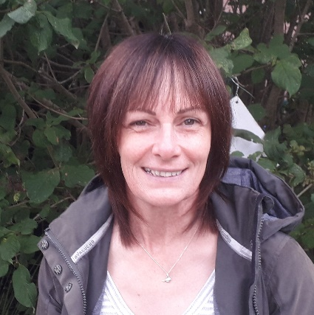
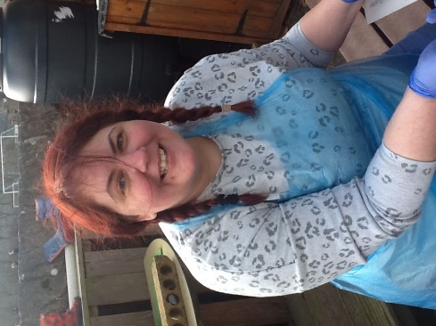
Miss Pringle
Early Years Practitioner
Mrs Duncan
Early Years Practitioner
Mrs Hammond
Early Years Practitioner

Mrs Pearson
Early Years Practitioner
Our Early Years Environment and Philosophy

At Echt nursery, we are very fortunate to have three large outdoor spaces.
A spacious garden with green house, mud kitchen, digging patch, planting area, bug hotel, sand pit and water play.
A hard surfaced area we use for ball games and wheeled vehicle play.
A landscaped area with two large sand play areas including our own boat, climbing frame and slide and crawling tunnel. This area also accommodates a summer house and a wooden playhouse.
We are proud to be known as an outdoor nursery with indoor space accessible if the weather takes a turn for the worse. Our philosophy is based around our children utilizing this outdoor to explore, lead and develop their own play and discovery.
We work in partnership with children and families to develop our learning, the environment, and next steps for each individual child. We believe in consulting with children so that they are empowered from an early age to make decisions for themselves, assess risk and lead their own learning.

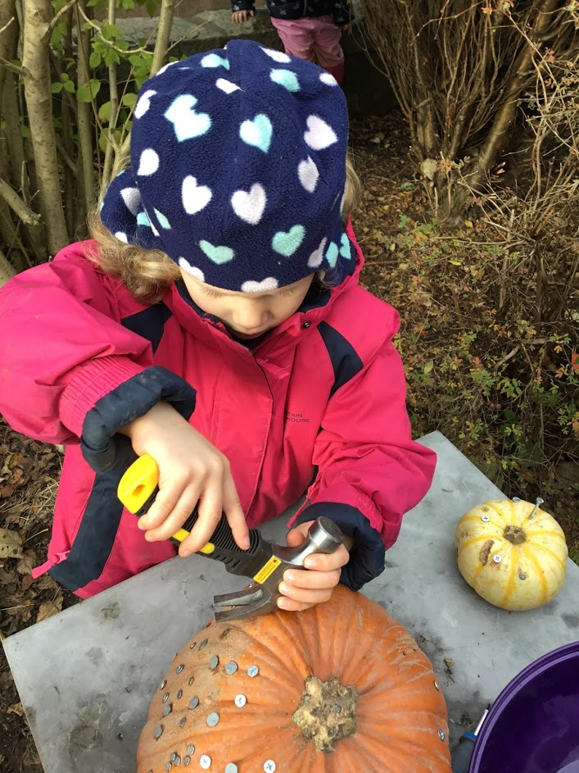
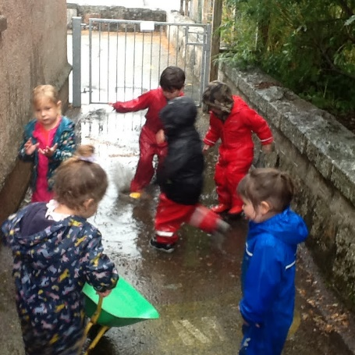
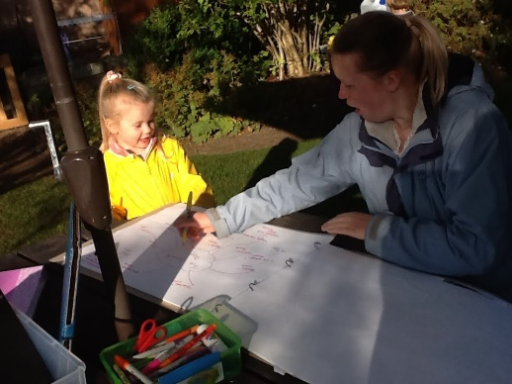
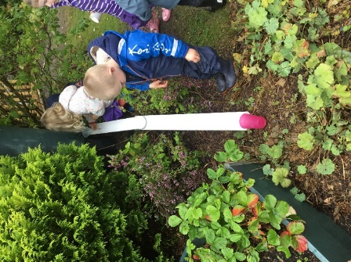

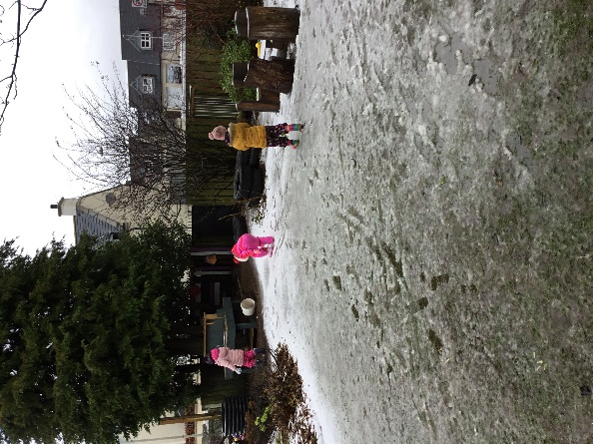

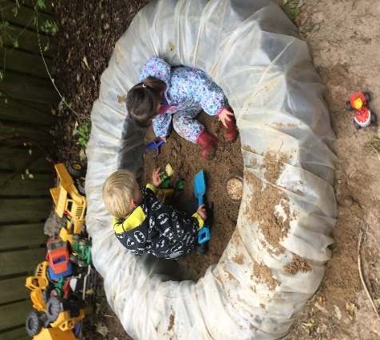
Curriculum for Excellence - Early Level.
Our nursery uses the national curriculum for Scotland. Learning is play based and child centred. This means that your child’s learning and development is experiential using the environment and mainly natural resources to allow them to explore and investigate, learning through doing. Adults will sometimes lead learning, but we very much encourage our children to become leaders of their own learning and therefore become thoroughly involved and motivated by their interests and fascinations.
The Curriculum for excellence is designed so that your children can become –
“Successful learners; confident individuals; responsible citizens and effective contributors.” CfE 2011
Learning and development are plotted against Aberdeenshire progression pathways. You will be able to access details of your childs progress through the electronic Learning Journals as it is noted on observations of their play and learning.

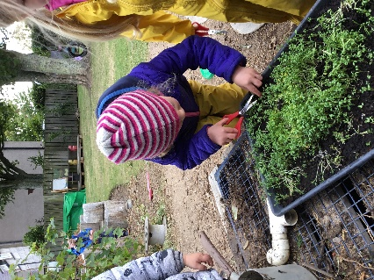

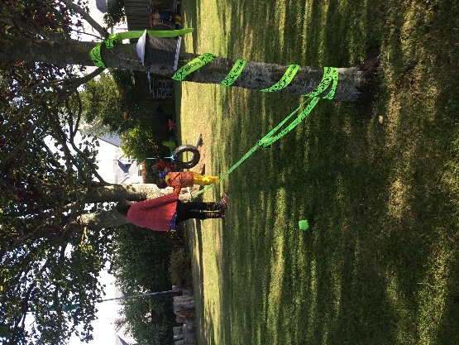

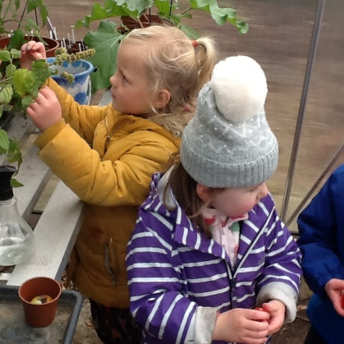

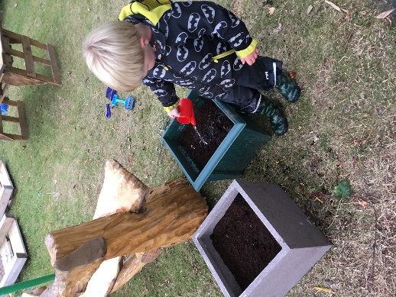
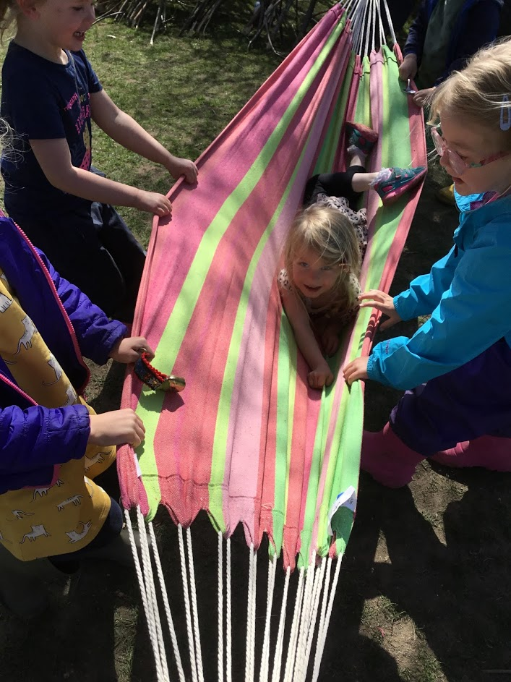

Nursery Snack
In accordance with Scottish policy, your child will be offered a healthy snack. Both morning and afternoon snacks is fruit based as it is provided by Aberdeenshire council. The morning snack is followed by a free school lunch and if your child attends the setting until 6pm they are offered a free supper.

Nursery Lunch
Children attending morning sessions are eligible to a free lunch funded by the Scottish government. Lunch choices are based on a healthy eating principle and children are encouraged to participate in a small group social lunch gathering. Families will be provided with nursery menus on a four-week rotation, so that you are aware of what your child has been offered every day. Your nursery Senior will discuss any dietary requirements your child may require according to prescribed food allergies.
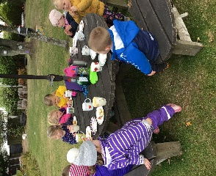
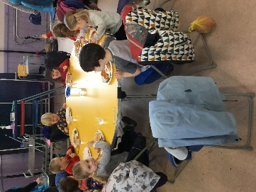
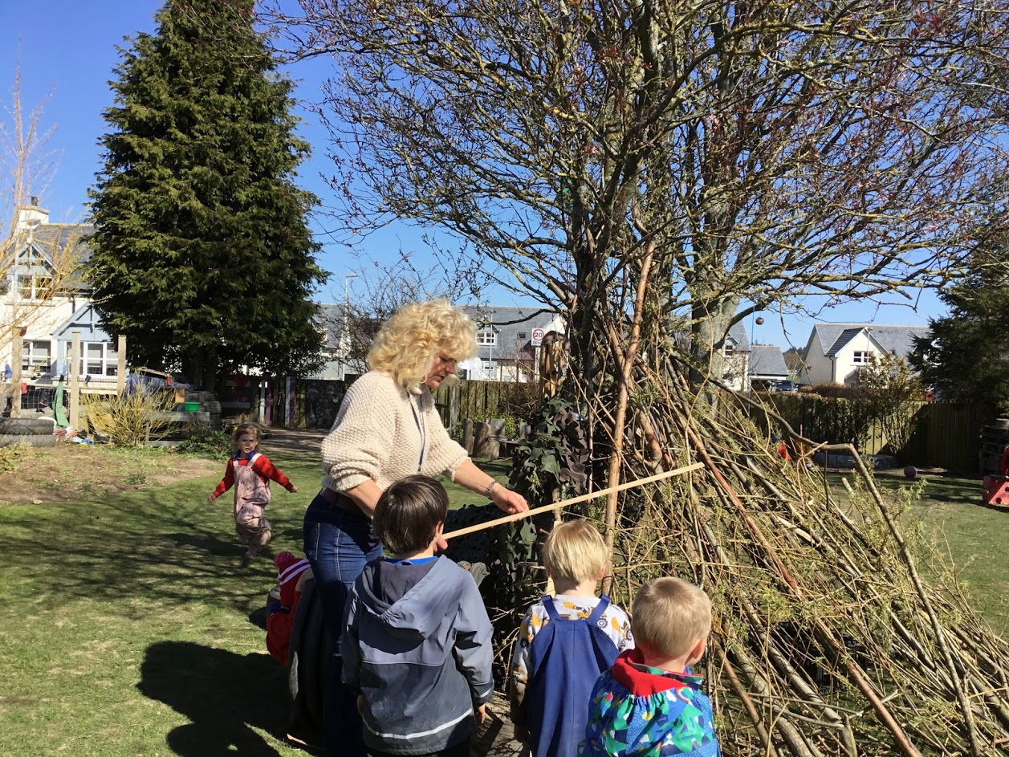

Home and Nursery Partnerships
Communications between home and nursery are carried out in many ways, the main 2 forms of communication that we use at Echt nursery is emails and your child’s learning journal. Your child’s learning journal will be set up by a member of the nursery team and you will have a link emailed to you so that you can log into your child’s personal account. This allows you to see the different observations taken by your child’s key worker and the other members of staff, their progression during their time with us, and any group activities that your child takes part in. Within this form of communication, you can add your own photos, comments, and like the images that you see. You will only see your own child’s learning journal through your own private log in details.

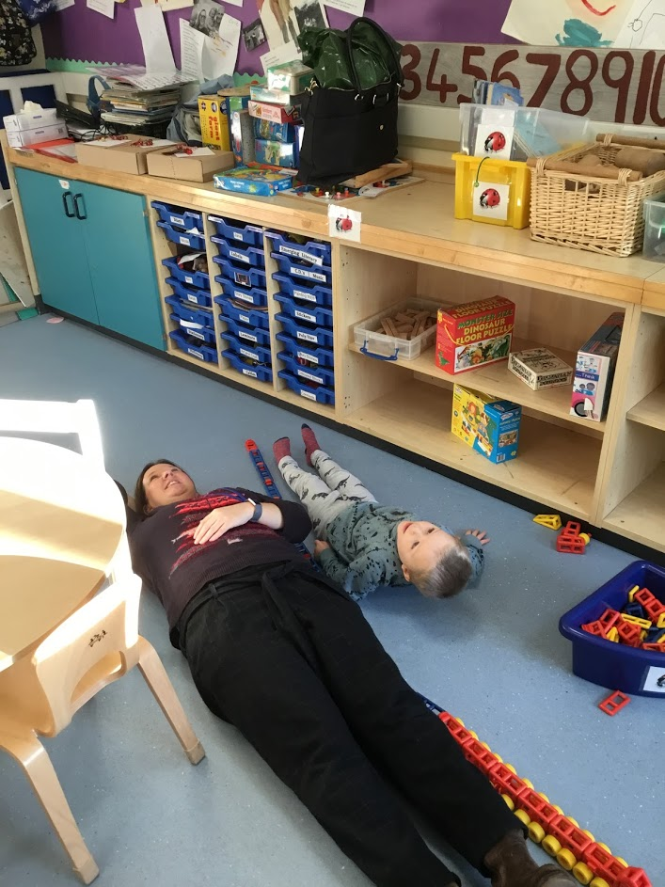

My Key Worker & All About Me.
Before your child begins their journey at Echt Nursery, you will receive a copy of our All About Me document to populate with information individual and special to your family’s picture. On joining nursery, we will observe how your child interacts with staff members and then they will be allocated with a Key Worker who is responsible for liaising with yourselves about your child’s developmental progress. The Key Worker is your point of contact and they are the staff member who will work most closely with your child to ensure they flourish in a supported environment which scaffolds their play and interests ongoing.

My Learning Journal.
Your child’s developmental profile is very important to us. We operate an electronic learning journal documenting observations, photographs and communicating with parents and carers day to day “Wow!” moments describing your child’s progress and significant moments when they have made notable changes to their skills and abilities.

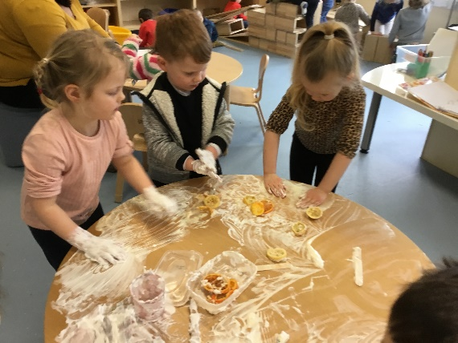

Belongings & Nursery Uniform
During the current pandemic we ask that all parents provide a change of clothes for their child in a named plastic carrier bag which we store in your child’s tray. Any unused clothing at the end of the school term will be returned to you to wash and then take in fresh clothing at the beginning of the following term.
We ask that all children attend the nursery setting dressed appropriately for the weather with either an all-in-one waterproof suit, or waterproof coat and trousers. We ask this because all children have access to water play and are encouraged to access this independently, waterproof clothing ensures that your child stays dry throughout the nursery session however, if they do get too hot then they are able to remove items of clothing to allow them to cool down.
We also encourage the children to take in their own water bottles filled with water so that they have access to it throughout the nursery day. All children are offered milk with their snacks and water with their lunches.

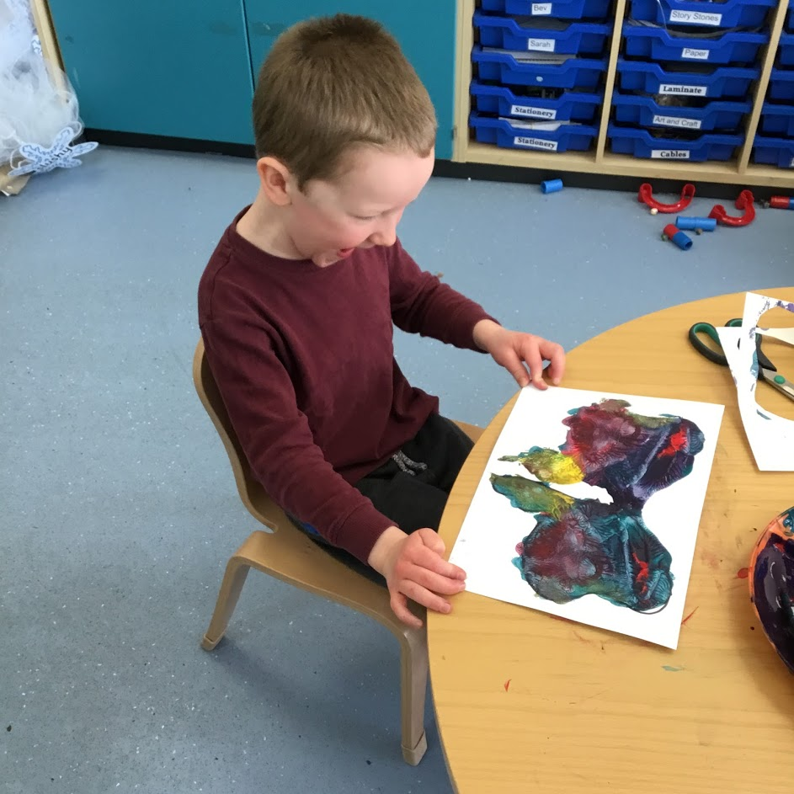

Safety and Security
Echt staff follow national and Aberdeenshire policy and procedure regarding risk assessment and providing a safe and secure environment where all our pupils can thrive at all times. COVID guidance has made us ever more vigilant. Due to restrictions registration is currently carried out by a member of nursery staff in the outdoor area. Nursery environments and resources are cleaned regularly and appropriately following COVID guidance, and as a parent you can rest assured that your child is protected at all times during the current situation. Risk assessments addressing COVID specific health and safety requirements are updated by senior staff regularly in line with national and local guidance
Health Matters
Please fill in the medical forms that we have sent to you fully including any allergies that your child has and what you do to help. Please only bring in your child’s medication if it is necessary for example if your child has been diagnosed with asthma or has allergies, These medications must be prescribed by your doctor before we can keep it on site. Please click on the below link for how long to keep your child off from nursery when ill.
Is my child too ill for school? - NHS (www.nhs.uk)
Starting Nursery
Children in their ante pre-school year (3-year olds) and in their immediate pre-school year (4-year olds) who live in CSN (Community School Network) area may be admitted to our Nursery. Where more applications than available places are received, children will be admitted by the local admissions panel following strict priority criteria. This is accordance with the revised Aberdeenshire Council policy.
Under the revised Aberdeenshire policy parents of anti-pre-school children still need to apply for a pre-school place if they are returning to the same setting. Applications: www.aberdeenshire.gov.uk/schools/information/early-learning-and-childcare-information
Attendance
Nursery attendance is not a legal requirement, but we would appreciate it if you could let us know by ringing nursery on 01330 700412 if you child will be absent as soon as possible at the start of the session.
Data Protection
On admission to nursery, we will seek your permission to use photographs/ video recording for the purpose of internal assessment and display. You will be required to sign consent forms which comply with current GDPR (General Data Protection Regulation).

Insurance
Council Statement for insurance:
No insurance is held by the Council to provide automatic compensation to pupils in the event of a personal accident or death. It is a parent’s responsibility to insure their child for personal accident or death if they feel this is appropriate. The Council does hold third party liability insurance that indemnifies the Council for claims for third parties (parents or pupils) who have suffered injury, illness, loss or damage arising from the Council or its employees, If however, there is negligence, no claim would be accepted by the Council.
Residual Risk
‘The planned excursion will take place according to Aberdeenshire Council’s Excursion Policy and a copy of the policy is available for inspection in Echt School or on the Council Web Site. The excursion has been risk assessed and every effort will be made to minimise risk. Nevertheless a totally risk free environment is unrealistic and in signing the parental consent form you are asked to acknowledge that a degree of residual risk remains. It is not anticipated that risks will exceed those incurred in normal day to day living.’

Child Protection

Everyone has a responsibility to protect children from harm. School and Nursery staff are in a unique position to contribute to the protection of children and must share concerns with appropriate colleagues and agencies.

Every school has a Designated Child Protection Officer (DCPO) who has been specifically trained to listen to concerns and act on them as necessary. In Echt Nursery it is the Early Years Senior Practitioner and Head Teacher. Unless satisfied that a child has not been harmed or is at risk of being harmed, the nursery/ school must relay their concerns immediately to the Social Work service and/ or the Police. Social Work and the Police will determine when and how the child’s parent/ carers and other services are to be informed of the concerns.

Local Social Work Office: 93 High Street, Inverurie. 01467 532888

Comments, Compliments, and Complaints
Echt Nursery is committed to delivering a quality service to all our users. We aim to take effective action to ensure standards are upheld and welcome being informed where they have not been satisfactory.

Our Complaints policy is displayed in the Nursery notice boards. We very much welcome comments about our service and how we operate, we continually evaluate our practice. We encourage parents to post comments on our How Good is Our Learning tree as well as responding to questionnaires and You said we did questions.

Aberdeenshire Council policy on Comments, Compliments and Complaints can be found on at www.aberdeenshire.gov.uk or a copy can be obtained from the school office.

We are regulated by the Care Inspectorate who can be contacted by:
Telephone: 0345 600 9527. Email: enquiries@careinspectorate.com.
www.careinspectorate.com

Thank you for taking the time to read our nursery handbook. We look forward
to getting to know your family and your child very soon! The Nursery Team

