Echt School

Child Protection Policy

Child Protection Guideline Policy
Introduction
Legislation and practice in child protection are underpinned by principles derived from articles of the United Nations Convention on the Rights of the Child.
Article 3
The best interests of the child must be a top priority in all things that affect children.
Article 12
Every child has the right to have a see in all matters affecting them and to have their views taken seriously
Article 13
Every child must be free to see what they think and to seek and receive all kinds of information as long as it is within the law.
Article 19
Governments must do all they can to ensure that children are protected from all forms of violence, abuse, neglect and bad treatment by their parents or anyone else who looks after them.
Article 36
Governments must protect children from all other forms of bad treatment.

In the context of these guidelines the term ‘Child Protection’ incorporates suspected as well as actual abuse of children. Somebody may abuse or neglect a child by inflicting, or by feeling to act to prevent significant harm to the child. Provided that there are reasonable grounds for suspicion each instance of actual or suspected child abuse must be reacted to and followed up as indicated in these guidelines.
All staff will receive child protection guidance for Echt School when they take up post. Following this training will be given annually at the start of each session. A copy of the training can be found on the shared drive. Categories of child abuse listed in the guidelines are physical injury, emotional abuse, sexual abuse and neglect. Where there is a possibility that a child could be at risk the school is required to follow strict procedures which are outlined by this policy. Any intervention by a public authority in the life of a child must be properly justified and should be supported by services from all relevant agencies working in collaboration.
Principles
- The first priority is the safety and wellbeing of each child. Management of suspected abuse must put the safety of the child first.
- All staff are responsible for the implementation of procedures.
- Prevention of abuse is as important as reacting to suspicions of abuse.
- Management of abuse should always reflect the possibility of criminal investigation and subsequent charges. However the safety of the child has overriding priority.
- The child’s views should always be listened to and taken seriously.
Procedures
- All educational establishments in Aberdeenshire designate a senior member of staff as responsible for coordinating action on child abuse within the establishment. At Echt School this is the head teacher. Referrals should normally be through this designated person but every employee has a responsibility to make a direct referral if this is necessary.
- If any member of staff has any concerns relating to a child at risk from any form of harm the following procedures must be followed.
- Discuss your concerns immediately with the child protection coordinator (CPC) Head Teacher.
- If they are not available then advice may be sought from another establishment Head Teacher – Mrs Elizabeth Shepherd – Midmar School.
- If the incident happens out of hours or it is not possible to speak to any school contacts then it is important that you do not wait but immediately contact the duty social worker or if you believe that a crime has taken place, contact the police directly.

3) The three key questions in child protection are
Is this child or young person at immediate risk?
What is placing this child at immediate risk?
What needs to happen to remove this risk now?

- In all cases incidents should be logged, action taken and recorded in line with the Child Protection Flow Chart (see Appendix 1).
- It is essential to maintain strict confidentiality in all child protection matters. Breach of confidentiality is a serious disciplinary matter and must be reported immediately to the line manager.
- The head of establishment should
- Ensure that all the staff including new staff on an ongoing basis are made familiar with the contents of this policy and a staff training record is maintained.
- Consider in the planning of any curricular provision designed around, for example social and life skills elements related to self-protection from risk of abuse.
- It is possible that employees are implicated in abuse. Indeed any adult or child may be an abuser and research shows that some abuse may be perpetrated by women or men or women and men acting in partnership. Disclosure should not be discounted because of the status or role of the alleged abuser.
Investigation by school staff only needs to establish evidence of the need to investigate abuse. Collection of evidence is a specialist police or social work role- inappropriate entries may prevent successful prosecution. A written record of incidents and action should be kept. The child protection flow chart included with this policy outlines the correct procedure to follow and correct forms to use.

GUIDELINES FOR STAFF DEALING WITH CHILD ABUSE
The following guidelines for dealing with disclosures have been devised to assist any member of staff who may have to respond to such a situation being brought to their attention.
Staff’s duty is to Observe, Record and Report.
Receive
Listen to what is being said without displaying shock or disbelief. Accept what is said. Take notes.
Reassure
Reassure the pupils but only so far as is honest and reliable, for example don't make any promises you may not be able to keep like “I'll stay with you” or “Everything will be alright”. Don't promise confidentiality. You have a duty to defer.
React
React to the pupil only as far as is necessary for you to establish whether or not you need to defer this matter but don't interrogate for full details.
Do not ask leading questions for example,
“What did he do next?” This assumes he did.
Such questions may invalidate your evidence and the child’s and any later prosecution in court.
Do ask open questions like “Anything else to tell me?” “ And?” “Yes?”
Do not ask the people to repeat at all for another member of staff.
Explain what you have to do next and who you have to talk to.

Record
Make some very brief notes at the time on any paper which comes to hand and write them up as soon as possible on the GC1 form.
Do not destroy your original notes in case are required by a court. Attach them to the GC1 form.
Record statements and observable things rather than your interpretations at assumptions.

Remember
To follow the Aberdeenshire Council guidelines.

Relax
Try to get some support for yourself if you need it.

Aberdeenshire Child Protection Protocol
Checklist for the Management of Child Protection and Educational Establishments
- Is there a named person responsible for Child Protection
Yes. Miss Margaret Cochrane - Head Teacher
- Is a copy of the Authority Child Protection Guidelines available for teachers, all other staff and parents?
Yes. PowerPoint available on shared area along with school policy. A copy is kept in the Head Teacher’s office.
- Is there an annual review of child protection requirements involving assessment of policy, assessment of training requirements and reminders to all staff about importance of policy?
Yes. August training annually.
- Are there arrangements to inform new and temporary staff about authority and establishment policy and the name and location of the designated person?
Yes. Staff induction ensures clear information is shared and new staff members will be
asked to read the policy.
- Are there appropriate curriculum experiences where children will learn about the value
of positive parenting?
Yes. Health and Wellbeing curriculum, Rights Respecting School work and awareness of the
Wellbeing Indicators.
- Do children know whom they can talk to about bullying or child protection matters in private?
Yes. Any member of staff or adult they trust. Children are made aware of Childline/NSPCC
through assembly talks from NSPCC and posters displayed in school.

Appendices
- Possible signs of a cause for concern
- Aberdeenshire Council Child Protection Flowchart procedures.
- GC1 Concern Sheet
- RC1 Child Protection Telephone Phone Checklist
- RR1 Child Protection Record of Referral Form

Appendix 1
Possible Signs of a Cause for Concern
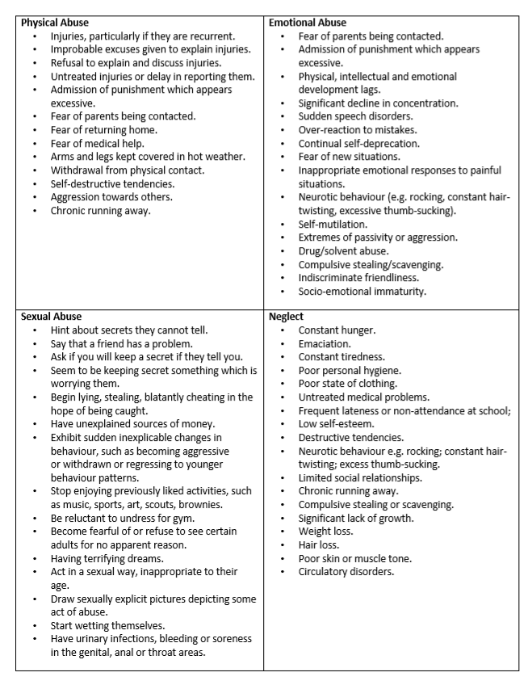
Appendix 2
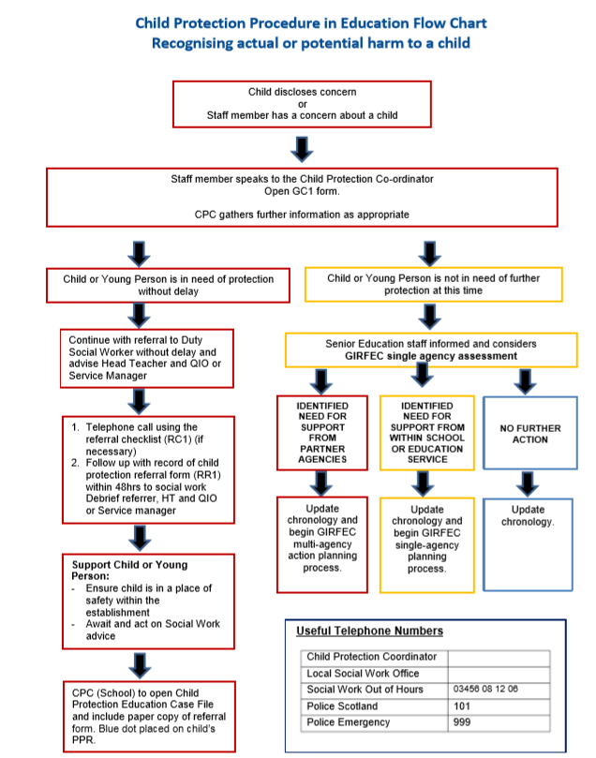

Appendix 3
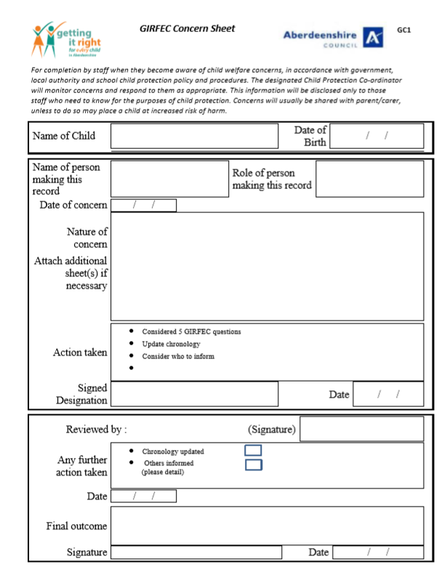

Appendix 4

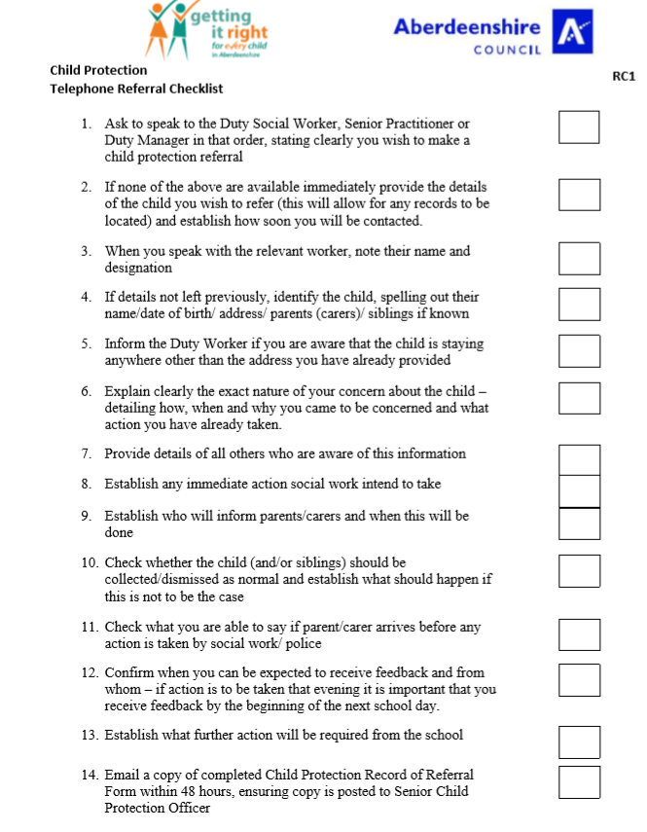

Appendix 5

